|  |  |  |  |
| --- | --- | --- | --- |
|  | | Test Report issued under the responsibility of: | |
| TEST REPORT **IEC 60598-2-5 Luminaires  Part 2: Particular requirements Section 5: Floodlights** | | |
|  |  | |
| **Report Number. :** | **240100055HZH-001** | |
| **Date of issue :** | **January 24, 2024** | |
| **Total number of pages** | **77** | |
|  | | |
| **Name of Testing Laboratory preparing the Report :** | Intertek Testing Services Zhejiang Ltd., Hangzhou Branch | |
| **Applicant’s name :** | Yuyao Tailian Lighting Electric Co.,Ltd | |
| **Address :** | No.2 Zhiyuan Road, Ditang Town, Yuyao, Zhejiang 315491,P.R. China | |
| **Test specification:** |  | |
| **Standard :** | IEC 60598-2-5:2015 used in conjunction with IEC 60598-1:2020  EN 60598-2-5: 2015 used in conjunction with EN IEC 60598-1:2021+ AMD11:2022 | |
| **Test procedure :** | CE-LVD | |
| **Non-standard test method :** | N/A | |
| **TRF template used :** | IECEE OD-2020-F1:2021, Ed.1.4 | |
| **Test Report Form No. :** | IEC60598_2_5G | |
| **Test Report Form(s) Originator :** | Intertek Semko AB | |
| **Master TRF :** | 2021-11-11 | |
| **Copyright © 2021 IEC System of Conformity Assessment Schemes for Electrotechnical Equipment and Components (IECEE System). All rights reserved.**  This publication may be reproduced in whole or in part for non-commercial purposes as long as the IECEE is acknowledged as copyright owner and source of the material. IECEE takes no responsibility for and will not assume liability for damages resulting from the reader's interpretation of the reproduced material due to its placement and context**.**  If this Test Report Form is used by non-IECEE members, the IECEE/IEC logo and the reference to the CB Scheme procedure shall be removed. | | |
| **General disclaimer:** | | |
| The test results presented in this report relate only to the object tested. This report shall not be reproduced, except in full, without the written approval of the Issuing NCB. The authenticity of this Test Report and its contents can be verified by contacting the NCB, responsible for this Test Report. | | |
|  | | |

|  |  |  |  |  |
| --- | --- | --- | --- | --- |
| **Test item description :** | | Portable luminaire | | |
| **Trade Mark(s) :** | | {name} | | |
| **Manufacturer :** | | Same as applicant above | | |
| **Model/Type reference :** | | ELT2935{age} | | |
| **Ratings :** | | 220-240V~, 50/60Hz, Class I, IP54, Max.35W | | |
|  | | | | |
| **Responsible Testing Laboratory (as applicable), testing procedure and testing location(s):** | | | | |
|  | **Testing Laboratory:** | | Intertek Testing Services Zhejiang Ltd., Hangzhou Branch | |
| **Testing location/ address :** | | | 4/F., Building 4, No. 22, 22nd Street, Qiantang District, Hangzhou, Zhejiang, China | |
| **Tested by (name, function, signature) :** | | | Fancy Zhu, Engineer |  |
| **Approved by (name, function, signature) :** | | | Jerry Chen, Reviewer |  |
|  | | | | |
|  | **Testing procedure: CTF Stage 1:** | |  | |
| **Testing location/ address :** | | |  | |
| **Tested by (name, function, signature) :** | | |  |  |
| **Approved by (name, function, signature) :** | | |  |  |
|  | | | | |
|  | **Testing procedure: CTF Stage 2:** | |  | |
| **Testing location/ address :** | | |  | |
| **Tested by (name + signature) :** | | |  |  |
| **Witnessed by (name, function, signature) :** | | |  |  |
| **Approved by (name, function, signature) :** | | |  |  |
|  | | | | |
|  | **Testing procedure: CTF Stage 3:** | |  | |
|  | **Testing procedure: CTF Stage 4:** | |  | |
| **Testing location/ address :** | | |  | |
| **Tested by (name, function, signature) :** | | |  |  |
| **Witnessed by (name, function, signature) :** | | |  |  |
| **Approved by (name, function, signature) :** | | |  |  |
| **Supervised by (name, function, signature) :** | | |  |  |
|  | | | | |

|  |  |
| --- | --- |
| List of Attachments (including a total number of pages in each attachment):  Attachment 1: EUROPEAN GROUP DIFFERENCES AND NATIONAL DIFFERENCES (Page 53-54)  Attachment 2: IEC/TR 62778: 2014: The assessment of blue light hazard to light sources and luminaires (Page 55-56)  Attachment 3: EN 62031 LED modules for general lighting – Safety specifications (Page 57 - page 58)  Attachment 4: EN 61347-2-11 Particular requirements for miscellaneous electronic circuits used with luminaires (Page 59)  Attachment 5: EN 61058 Evaluation (page 60 - page 64)  Attachment 6: Requirement of EN 60598-2-4 MOD (page 65)  Attachment 7: Photos (Page 66-75) Attachment 8: Circuit diagram and PCB layout (Page 66-77) | |
| **Summary of testing:**  The products covered by this report have been tested and comply with the applicable requirements of this standard.  Some representative samples of models covered by this report have been tested and comply with the applicable requirements of this standard.  All tests are applied to typical model ELT2935 with alternate LED modules which give the most unfavourable test results.  The produce will not overturn when it is placing on a plane at an angle of 15º to the horizontal.  The blue light hazard of incorporated LED has been evaluated according to IEC/TR 62778 and grouped as RG1.  According to clause 4.2.2 of EN 62493:2015+A1:2022, these products are incorporating with LED light source and deemed to comply with the requirements of EN 62493:2015+A1:2022 without testing. | |
| **Tests performed (name of test and test clause):**  All | **Testing location:**  Same as previous page. |
| **Summary of compliance with National Differences (List of countries addressed):**  **The product fulfils the requirements of IEC 60598-2-5:2015 used in conjunction with IEC 60598-1:2020, EN 60598-2-5: 2015 used in conjunction with EN IEC 60598-1:2021+ AMD11:2022.** | |

|  |
| --- |
| **Copy of marking plate:**  Sample:  For VDE pulg and VDE socket  Near the socket outlet:  Near the USB:  Note 1: Height of letter and numeral is not less than 2mm, graphical symbol is not less than 5mm, WEEE symbol is not less than 7mm.  According to the EU directives which have been aligned with EU NLF (new legislative framework), both of manufacturer and importer‘name and address shall be affixed on the product or, where that is not possible, on its packaging or in a document accompanying the product before the product is placed on the EU market. |

|  |  |
| --- | --- |
| **Test item particulars :** | Portable luminaire |
| **Classification of installation and use :** | IP54, Class I |
| **Supply Connection :** | Supply cord |
| **Possible test case verdicts:** |  |
| **- test case does not apply to the test object :** | N/A |
| **- test object does meet the requirement :** | P (Pass) |
| **- test object does not meet the requirement :** | F (Fail) |
| **Testing :** |  |
| **Date of receipt of test item :** | January 03, 2024 |
| **Date (s) of performance of tests :** | January 03, 2024 to January 24, 2024 |
|  | |
| **General remarks:** | |
| "(See Enclosure #)" refers to additional information appended to the report. "(See appended table)" refers to a table appended to the report.  **Throughout this report a  comma /  point is used as the decimal separator.**  **Clause numbers between brackets refer to clauses in IEC 60598-1**  **Disclaimer:**  This report is for the exclusive use of Intertek's Client and is provided pursuant to the agreement between Intertek and its Client. Intertek's responsibility and liability are limited to the terms and conditions of the agreement. Intertek assumes no liability to any party, other than to the Client in accordance with the agreement, for any loss, expense or damage occasioned by the use of this report. Only the Client is authorized to permit copying or distribution of this report and then only in its entirety. Any use of the Intertek name or one of its marks for the sale or advertisement of the tested material, product or service must first be approved in writing by Intertek. The observations and test results in this report are relevant only to the sample tested. This report by itself does not imply that the material, product, or service is or has ever been under an Intertek certification program.  Clause numbers between brackets refer to clauses in IEC 60598-1  Determination of the test conclusion is based on IEC Guide 115 in consideration of measurement uncertainty. | |
| **Manufacturer’s Declaration per sub-clause 4.2.5 of IECEE 02:** | |
| The application for obtaining a CB Test Certificate includes more than one factory location and a declaration from the Manufacturer stating that the sample(s) submitted for evaluation is (are) representative of the products from each factory has been provided : | **Yes**  **Not applicable** |
| **When differences exist; they shall be identified in the General product information section.** | |
| **Name and address of factory (ies) :** | Yuyao Tailian Lighting Electric Co.,Ltd  No.2 Zhiyuan Road, Ditang Town, Yuyao, Zhejiang 315491,P.R. China |
| General product information and other remarks:  LED Floodlights are for normal use, with a socket output max3580W, rated current: max16A, USB Output: 5VDC 1A.  These products are only intended for normal use, must not be used for rough service.  The produce will not overturn when it is placing on a plane at an angle of 15º to the horizontal.   |  |  |  |  | | --- | --- | --- | --- | |  |  |  |  | |  |  |  |  | |  |  |  |  | |  |  |  |  | | |

|  |  |  |  |
| --- | --- | --- | --- |
| **5.2 (0)** | **GENERAL TEST REQUIREMENTS** | |  |
| 5.2 (0.3) | More sections applicable : | Yes  No  Section/s: EN 60598-2-4 | ⎯ |
| 5.2 (0.5) | Components | (see Annex 1) | ⎯ |
| **5.2 (0.7)** | **Information for luminaire design in light sources standards** | | ⎯ |
| 5.2 (0.7.2) | Light source safety standard : | EN 62031 | ⎯ |
|  | Luminaire design in the light source safety standard |  | P |
|  | | | |
| **5.4 (2)** | **CLASSIFICATION OF LUMINAIRES** | |  |
| 5.4 (2.2) | Type of protection : | Class I | P |
| 5.4 (2.3) | Degree of protection : | IP54 | P |
| 5.4 (2.4) | Luminaire suitable for direct mounting on normally flammable surfaces : | Yes  No | ⎯ |
| 5.4 (2.5) | Luminaire for normal use : | Yes  No | ⎯ |
|  | Luminaire for rough service : | Yes  No | ⎯ |
|  | | | |
| **5.5 (3)** | **MARKING** | |  |
| 5.5 (3.2) | Mandatory markings |  | P |
|  | Position of the marking | On the enclosure | P |
|  | Format of symbols/text |  | P |
| 5.5 (3.3) | Additional information |  | P |
|  | Language of instructions | English | P |
| 5.5 (3.3.1) | Combination luminaires |  | N/A |
| 5.5 (3.3.2) | Nominal frequency in Hz | 50/60Hz | P |
| 5.5 (3.3.3) | Operating temperature |  | N/A |
| 5.5 (3.3.5) | Wiring diagram |  | N/A |
| 5.5 (3.3.6) | Special conditions |  | N/A |
| 5.5 (3.3.7) | Metal halide lamp luminaire – warning |  | N/A |
| 5.5 (3.3.8) | Limitation for semi-luminaires |  | N/A |
| 5.5 (3.3.9) | Power factor and supply current |  | N/A |
| 5.5 (3.3.10) | Suitability for use indoors |  | N/A |
| 5.5 (3.3.11) | Luminaires with remote control |  | N/A |
| 5.5 (3.3.12) | Clip-mounted luminaire – warning |  | N/A |
| 5.5 (3.3.13) | Specifications of protective shields |  | N/A |
| 5.5 (3.3.14) | Symbol for nature of supply | ~ | P |
| 5.5 (3.3.15) | Rated current of socket outlet |  | N/A |
| 5.5 (3.3.16) | Rough service luminaire |  | N/A |
| 5.5 (3.3.17) | Mounting instruction for type Y, type Z and some type X attachments | Type Y | P |
| 5.5 (3.3.18) | Non-ordinary luminaires with PVC cable |  | N/A |
| 5.5 (3.3.19) | Protective conductor current in instruction if applicable |  | N/A |
| 5.5 (3.3.20) | Provided with information if not intended to be mounted within arm’s reach |  | N/A |
| 5.5 (3.3.21) | Non replaceable and non-user replaceable light sources information provided | non-user replaceable | P |
| 5.5 (3.3.22) | Controllable luminaires, classification of insulation provided |  | N/A |
| 5.5 (3.3.23) | Luminaires without control gear provided with necessary information for selection of appropriate component |  | N/A |
| 5.5 (3.3.24) | If not supplied with terminal block, information on the packaging |  | N/A |
| 5.5 (3.3.25) | Luminaires employing light sources emitting UV on mains wiring, information provided |  | N/A |
| 5.5 (3.3.26) | Wall mounted luminaire using external flexible cable or cord longer than 0.3 m, information provided |  | N/A |
| 5.5 (3.4) | Test with water |  | P |
|  | Test with hexane |  | P |
|  | Legible after test |  | P |
|  | Label attached |  | P |
| 5.5 (-) | Additional information if applicable | | P |
|  | a) Operation position |  | P |
|  | b) Weight and dimensions |  | P |
|  | c) Maximum protected area |  | P |
|  | d) Limitation of use indoors and/or outdoor |  | P |
|  | e) Maximum mounting height if ≤ 5 m |  | P |
|  | | | |
| **5.6 (4)** | **CONSTRUCTION** | |  |
| 5.6 (4.2) | Components replaceable without difficulty |  | N/A |
| 5.6 (4.3) | Wireways smooth and free from sharp edges |  | P |
| **5.6 (4.4)** | **Lampholders** | | N/A |
| 5.6 (4.4.1) | Integral lampholder |  | N/A |
| 5.6 (4.4.2) | Wiring connection |  | N/A |
| 5.6 (4.4.3) | Lampholder for end‑to‑end mounting |  | N/A |
| 5.6 (4.4.4) | Positioning |  | N/A |
|  | - pressure test (N) : |  | — |
|  | After test the lampholder comply with relevant standard sheets and show no damage |  | N/A |
|  | After test on single-capped lampholder the lampholder have not moved from its position and show no permanent deformation |  | N/A |
|  | - bending test (N) : |  | — |
|  | After test the lampholder have not moved from its position and show no permanent deformation |  | N/A |
| 5.6 (4.4.5) | Peak pulse voltage |  | N/A |
| 5.6 (4.4.6) | Centre contact |  | N/A |
| 5.6 (4.4.7) | Parts in rough service luminaires resistant to tracking |  | N/A |
| 5.6 (4.4.8) | Lamp connectors |  | N/A |
| 5.6 (4.4.9) | Caps and bases correctly used |  | N/A |
| 5.6 (4.4.10) | Light source for lampholder or connection according IEC 60061 not connected another way |  | N/A |
| **5.6 (4.5)** | **Starter holders** | | N/A |
|  | Starter holder in luminaires other than class II |  | N/A |
|  | Starter holder class II construction |  | N/A |
| **5.6 (4.6)** | **Terminal blocks** | | N/A |
|  | Tails |  | N/A |
|  | Unsecured blocks |  | N/A |
| **5.6 (4.7)** | **Terminals and supply connections** | | P |
| 5.6 (4.7.1) | Contact to metal parts | Cable gland | P |
| 5.6 (4.7.2) | Test 8 mm live conductor |  | P |
|  | Test 8 mm earth conductor |  | P |
| 5.6 (4.7.3) | Terminals for supply conductors |  | N/A |
| 5.6 (4.7.3.1) | Welded method and material | | N/A |
|  | - stranded or solid conductor |  | N/A |
|  | - spot welding |  | N/A |
|  | - welding between wires |  | N/A |
|  | - Type Z attachment |  | N/A |
|  | - mechanical test according to 15.6.2 |  | N/A |
|  | - electrical test according to 15.6.3 |  | N/A |
|  | - heat test according to 15.6.3.2.3 and 15.6.3.2.4 |  | N/A |
| 5.6 (4.7.4) | Terminals other than supply connection |  | N/A |
| 5.6 (4.7.5) | Heat-resistant wiring/sleeves |  | N/A |
| 5.6 (4.7.6) | Multi-pole plug |  | N/A |
|  | - test at 30 N |  | N/A |
| **5.6 (4.8)** | **Switches** | | P |
|  | - adequate rating |  | P |
|  | - adequate fixing |  | P |
|  | - polarized supply |  | P |
|  | - compliance with IEC 61058-1 for electronic switches |  | P |
| **5.6 (4.9)** | **Insulating lining and sleeves** | | N/A |
| 5.6 (4.9.1) | Retainment |  | N/A |
|  | Method of fixing : |  | N/A |
| 5.6 (4.9.2) | Insulated linings and sleeves: | | N/A |
|  | Resistant to a temperature > 20 °C to the wire temperature or |  | N/A |
|  | a) & c) Insulation resistance and electric strength |  | N/A |
|  | b) Ageing test. Temperature (°C) : |  | N/A |
| **5.6 (4.10)** | **Double or reinforced insulation** | | P |
| 5.6 (4.10.1) | No contact, mounting surface – accessible metal parts – wiring of basic insulation |  | P |
|  | Safe installation fixed luminaires |  | N/A |
|  | Capacitors and switches |  | N/A |
| 5.6 (4.10.2) | Assembly gaps: | | P |
|  | ‑ not coincidental |  | P |
|  | ‑ no straight access with test probe |  | P |
| 5.6 (4.10.3) | Retainment of insulation: | | N/A |
|  | ‑ fixed |  | N/A |
|  | ‑ unable to be replaced; luminaire inoperative |  | N/A |
|  | ‑ sleeves retained in position |  | N/A |
|  | ‑ lining in lampholder |  | N/A |
| 5.6 (4.10.4) | Protective impedance device | | N/A |
|  | Basic and supplementary insulation bridged by resistor(s) or appropriate capacitor |  | N/A |
|  | Double or reinforced insulation bridged by appropriate and at least two resistors or two Y2 capacitors or one Y1 capacitor |  | N/A |
|  | Capacitors comply with IEC 60384-14 |  | N/A |
|  | Resistors comply with test (a) in 14.1 of IEC 60065 |  | N/A |
| **5.6 (4.11)** | **Electrical connections and current-carrying parts** | | P |
| 5.6 (4.11.1) | Contact pressure |  | P |
| 5.6 (4.11.2) | Screws: | | N/A |
|  | ‑ self-tapping screws |  | N/A |
|  | ‑ thread‑cutting screws |  | N/A |
| 5.6 (4.11.3) | Screw locking: | | P |
|  | ‑ spring washer |  | N/A |
|  | ‑ rivets |  | N/A |
| 5.6 (4.11.4) | Material of current-carrying parts |  | P |
| 5.6 (4.11.5) | No contact to wood or mounting surface |  | P |
| 5.6 (4.11.6) | Electro-mechanical contact systems |  | N/A |
| **5.6 (4.12)** | **Screws and connections (mechanical) and glands** | | P |
| 5.6 (4.12.1) | Screws not made of soft metal |  | P |
|  | Screws of insulating material |  | N/A |
|  | Torque test: torque (Nm); part : | Fixing LED PCB, 0,5Nm | P |
|  | Torque test: torque (Nm); part : | Fixing enclosure, 0,5Nm | P |
|  | Torque test: torque (Nm); part : | Fixing earth terminal, 0,5Nm | P |
|  | Torque test: torque (Nm); part : | Fixing lamp shade, 0,5Nm | P |
|  | Torque test: torque (Nm); part : | Fixing switch, 0,5Nm | P |
| 5.6 (4.12.2) | Screws with diameter < 3 mm screwed into metal |  | N/A |
| 5.6 (4.12.4) | Locked connections: | | P |
|  | - fixed arms; torque (Nm) : | 2,5Nm | P |
|  | - lampholder; torque (Nm) : |  | N/A |
|  | - push-button switches; torque 0,8 Nm : |  | N/A |
| 5.6 (4.12.5) | Screwed glands; force (Nm) : |  | N/A |
| **5.6 (4.13)** | **Mechanical strength** | | P |
| 5.6 (4.13.1) | Impact tests: | | P |
|  | ‑ fragile parts; energy (Nm) : | 0,5Nm | P |
|  | ‑ other parts; energy (Nm) : | 0,7Nm | P |
|  | 1) live parts |  | P |
|  | 2) linings |  | N/A |
|  | 3) protection |  | P |
|  | 4) covers |  | P |
| 5.6 (4.13.2) | Metal parts have adequate mechanical strength |  | P |
| 5.6 (4.13.3) | Straight test finger | 30N | P |
| 5.6 (4.13.4) | Rough service luminaires | | N/A |
|  | - IP54 or higher |  | N/A |
|  | a) fixed |  | N/A |
|  | b) hand-held |  | N/A |
|  | c) delivered with a stand |  | N/A |
|  | d) for temporary installations and suitable for mounting on a stand |  | N/A |
| 5.6 (4.13.6) | Tumbling barrel |  | N/A |
| **5.6 (4.14)** | **Suspensions, fixings and means of adjusting** | | N/A |
| 5.6 (4.14.1) | Mechanical load: | | N/A |
|  | A) four times the weight |  | N/A |
|  | B) torque 2,5 Nm |  | N/A |
|  | C) bracket arm; bending moment (Nm) : |  | N/A |
|  | D) load track‑mounted luminaires |  | N/A |
|  | E) clip-mounted luminaires, glass-shelve. Thickness (mm) : |  | N/A |
|  | Metal rod. diameter (mm) : |  | N/A |
|  | Fixed luminaire or independent control gear without fixing devices |  | N/A |
| 5.6 (4.14.2) | Load to flexible cables | | N/A |
|  | Mass (kg) : | N/A | — |
|  | Stress in conductors (N/mm²) : |  | N/A |
|  | Mass (kg) of semi-luminaire : |  | N/A |
|  | Bending moment (Nm) of semi-luminaire : |  | N/A |
| 5.6 (4.14.3) | Adjusting devices: | | N/A |
|  | ‑ flexing test; number of cycles : |  | N/A |
|  | ‑ strands broken : |  | N/A |
|  | ‑ electric strength test afterwards |  | N/A |
| 5.6 (4.14.4) | Telescopic tubes: cords not fixed to tube; no strain on conductors |  | N/A |
| 5.6 (4.14.5) | Guide pulleys |  | N/A |
| 5.6 (4.14.6) | Strain on socket-outlets |  | N/A |
| **5.6 (4.15)** | **Flammable materials** | | P |
|  | ‑ glow‑wire test 650°C : | See Test Table 5.15 (13.3.2) | P |
|  | ‑ spacing ≥30 mm |  | N/A |
|  | ‑ screen withstanding test of 13.3.1 |  | N/A |
|  | ‑ screen dimensions |  | N/A |
|  | ‑ no fiercely burning material |  | P |
|  | ‑ thermal protection |  | N/A |
|  | ‑ electronic circuits exempted |  | N/A |
| 5.6 (4.15.2) | Luminaires made of thermoplastic material with lamp control gear | | N/A |
|  | a) construction |  | N/A |
|  | b) temperature sensing control |  | N/A |
|  | c) surface temperature |  | N/A |
| **5.6 (4.16)** | **Luminaires for mounting on normally flammable surfaces** | | P |
|  | No lamp control gear : | (compliance with Section 12) | P |
|  | Provided with adaptor for a track meet the requirements for direct mounting on normally flammable surfaces |  | N/A |
| 5.6 (4.16.1) | Lamp control gear spacing: | | N/A |
|  | ‑ spacing 35 mm |  | N/A |
|  | ‑ spacing 10 mm |  | N/A |
| 5.6 (4.16.2) | Thermal protection: | | N/A |
|  | - in lamp control gear |  | N/A |
|  | - external |  | N/A |
|  | - fixed position |  | N/A |
|  | - temperature marked lamp control gear |  | N/A |
| 5.6 (4.16.3) | Design to satisfy the test of 12.6 | (see clause 12.6) | N/A |
| **5.6 (4.17)** | **Drain holes** | | N/A |
|  | Clearance at least 5 mm |  | N/A |
| **5.6 (4.18)** | **Resistance to corrosion** | | P |
| 5.6 (4.18.1) | - rust‑resistance |  | P |
| 5.6 (4.18.2) | - season cracking in copper |  | P |
| 5.6 (4.18.3) | - corrosion of aluminium |  | P |
| 5.6 (4.19) | Ignitors compatible with ballast |  | N/A |
| 5.6 (4.20) | Rough service vibration |  | N/A |
| **5.6 (4.21)** | **Protective shield** | | N/A |
| 5.6 (4.21.1) | Shield fitted if tungsten halogen lamps or metal halide lamps |  | N/A |
|  | Shield of glass if tungsten halogen lamps |  | N/A |
| 5.6 (4.21.2) | Particles from a shattering lamp not impair safety |  | N/A |
| 5.6 (4.21.3) | No direct path |  | N/A |
| 5.6 (4.21.4) | Impact test on shield |  | N/A |
|  | Glow-wire test on lamp compartment : | See Test Table 5.15 (13.3.2) | N/A |
| 5.6 (4.22) | Attachments to lamps not cause overheating or damage |  | N/A |
| 5.6 (4.23) | Semi-luminaires comply Class II |  | N/A |
| **5.6 (4.24)** | **Photobiological hazards** | | P |
| 5.6 (4.24.1) | No excessive UV radiation if tungsten halogen lamps and metal halide lamps (Annex P) |  | P |
| 5.6 (4.24.2) | Retinal blue light hazard | | P |
|  | Class of risk group assessed according to IEC/TR 62778 : | RG1 | — |
|  | Luminaires with *E*thr : | | N/A |
|  | a) Fixed luminaires |  | N/A |
|  | - distance x m, borderline between RG1 and RG2 : |  | N/A |
|  | - marking and instruction according 3.2.23 |  | N/A |
|  | b) Portable and handheld luminaires |  | P |
|  | - marking according 3.2.23 if RG1 exceeded at 200 mm according to IEC/TR 62778 |  | N/A |
|  | Portable luminaires for children IEC 60598-2-10 and Mains socket outlet nightlights IEC 60598-2-12 not exceed RG1 at 200 mm according to IEC/62778 |  | N/A |
| **5.6 (4.25)** | **Mechanical hazard** | | P |
|  | No sharp point or edges |  | P |
| **5.6 (4.26)** | **Short-circuit protection** | | N/A |
| 5.6 (4.26.1) | Adequate means of uninsulated accessible SELV parts |  | N/A |
| 5.6 (4.26.2) | Short-circuit test with test chain according 4.26.3 | | N/A |
|  | Supply source ES1 PSE |  | N/A |
|  | Test chain not melt through |  | N/A |
|  | Test sample not exceed values of Table 12.1 and 12.2 |  | N/A |
| **5.6 (4.27)** | **Terminal blocks with integrated screwless earthing contacts** | | N/A |
|  | Test according Annex V |  | N/A |
|  | Pull test of terminal fixing (20 N) |  | N/A |
|  | After test, resistance < 0,05 Ω |  | N/A |
|  | Pull test of mechanical connection (50 N) |  | N/A |
|  | After test, resistance < 0,05 Ω |  | N/A |
|  | Voltage drop test, resistance < 0,05 Ω |  | N/A |
| **5.6 (4.28)** | **Fixing of thermal sensing control** | | N/A |
|  | Not plug-in or easily replaceable type |  | N/A |
|  | Reliably kept in position |  | N/A |
|  | No adhesive fixing if UV radiations from a lamp can degrade the fixing |  | N/A |
|  | Not outside the luminaire enclosure |  | N/A |
|  | Test of adhesive fixing: | | N/A |
|  | Max. temperature on adhesive material (°C) : |  | — |
|  | 100 cycles between t min and t max |  | N/A |
|  | Temperature sensing control still in position |  | N/A |
| **5.6 (4.29)** | **Luminaires with non-replaceable light source** | | N/A |
|  | Not possible to replace light source |  | N/A |
|  | Live part not accessible after parts have been opened by hand or tools |  | N/A |
| **5.6 (4.30)** | **Luminaires with non-user replaceable light source** | | P |
|  | If protective cover provide protection against electric shock and marked with “caution, electric shock risk” symbol: | | P |
|  | At least one fixing means requiring use of tool |  | P |
| **5.6 (4.31)** | **Insulation between circuits** | |  |
|  | Circuits insulated from LV supply fulfil requirements according 4.31.1 – 4.31.3 |  | P |
|  | Controllable luminaires requiring same level of insulation for all components, the insulation between control terminals and LV supply fulfil requirements according 4.31.1 – 4.31.3 |  | N/A |
| 5.6 (4.31.1) | SELV or PELV circuits | | N/A |
|  | Used SELV/PELV source |  | N/A |
|  | Voltage ≤ ELV |  | N/A |
|  | Insulating of SELV/PELV circuits from LV supply |  | N/A |
|  | Insulating of SELV/PELV circuits from other non SELV/PELV circuits |  | N/A |
|  | Insulating of SELV/PELV circuits from FELV |  | N/A |
|  | Insulating of SELV/PELV circuits from other SELV/PELV circuits |  | N/A |
|  | SELV/PELV circuits insulated from accessible parts according Table X.1 |  | N/A |
|  | Plugs not able to make any electrical contact with socket-outlets of other voltage systems |  | N/A |
|  | Socket outlets does not admit plugs of other voltage systems |  | N/A |
|  | Plugs and socket-outlets does not have protective conductor contact |  | N/A |
| 5.6 (4.31.2) | FELV circuits | | N/A |
|  | Used FELV source |  | N/A |
|  | Voltage ≤ ELV |  | N/A |
|  | Insulating of FELV circuits from LV supply |  | N/A |
|  | FELV circuits insulated from accessible parts according Table X.1 |  | N/A |
|  | Plugs not able to make any electrical contact with socket-outlets of other voltage systems |  | N/A |
|  | Socket outlets does not admit plugs of other voltage systems |  | N/A |
|  | Socket-outlets does not have protective conductor contact |  | N/A |
| 5.6 (4.31.3) | Other circuits | | P |
|  | Other circuits insulated from accessible parts according Table X.1 |  | P |
|  | Class II construction with equipotential bonding for protection against indirect contacts with live parts: | | N/A |
|  | - conductive parts are connected together |  | N/A |
|  | - test according 7.2.3 |  | N/A |
|  | - conductive part not cause an electric shock in case of an insulation fault |  | N/A |
|  | - equipotential bonding in master/slave applications |  | N/A |
|  | - master luminaire provided with terminal for accessible conductive parts of slave luminaires |  | N/A |
|  | - slave luminaire constructed as class I |  | N/A |
| **5.6 (4.32)** | **Overvoltage protective devices** | | N/A |
|  | Comply with IEC 61643-11 |  | N/A |
|  | External to controlgear and connected to earth: | | N/A |
|  | - only in fixed luminaires |  | N/A |
|  | - only connected to protective earth |  | N/A |
| **5.6 (4.33)** | **Luminaire powered via information technology communication cabling** | | N/A |
|  | Requirements for Class III luminaire |  | N/A |
|  | Rated voltage within the range of ES1 and does not exceed maximum voltage of used connector |  | N/A |
|  | Luminaire does not create any hazard from overvoltage | (see Annex 2) | N/A |
| **5.6 (4.34)** | **Electromagnetic fields (EMF)** | | P |
|  | No harmful electromagnetic fields |  | P |
| **5.6 (4.35)** | **Protection against moving fan blades** | | N/A |
|  | Test with a standard test finger |  | N/A |
|  | Test with test probe acc. to Figure 13 (IEC 61032) for portable luminaire |  | N/A |
|  | Blades rounded with radius ≥ 0.5 mm and: | | N/A |
|  | -hardness less than D60 Shore |  | N/A |
|  | -peripheral speed less than 15 m/s |  | N/A |
|  | -input power of fan ≤ 2 W at rated voltage |  | N/A |
| **5.6 (4.36)** | **Track-mounted luminaires** | | N/A |
|  | Test in accordance with Annex A of IEC60570:2003/AMD2:2019 |  | N/A |
| 5.6.1 (-) | At least IPX3 if for outdoor use |  | P |
| 5.6.2 (-) | Lampholder brackets and lamp supports |  | N/A |
| 5.6.3 (-) | Adjusting means |  | P |
| 5.6.4 (-) | Controlling components |  | P |
| 5.6.5 (-) | Fixing device |  | P |
|  | Wind force test |  | P |
| 5.6.6 (‑) | Locking of angular adjustment |  | P |
| 5.6.7 (-) | Vibration resistance |  | P |
| 5.6.8 (-) | Requirement on glass cover if mounting height > 5 m |  | N/A |
|  | Method of protection : | Glass cover | ⎯ |
|  | | | |
| **5.7 (11)** | **CREEPAGE DISTANCES AND CLEARANCES** | |  |
| 5.7 (11.2) | Creepage distances and clearances : | See Table 5.7 (11.2) | N/A |
|  | Impulse withstand category (Normal category II) (Category III Annex U, Table U.1) | Category II  Category III | ⎯ |
|  | Protected against pollution, reduced creepage and clearance according Annex P of IEC 61347-1 |  | N/A |
| 5.7 (11.2.2) | Creepage distances for frequency up to 30 kHz | See Test Table 5.7 (11.2) I | P |
|  | Creepage distances for frequency over 30 kHz: | | N/A |
|  | - Controlgear marked with *Û*OUT and *f*UOUT according IEC 61347-1, clause 7.1, item w | See Test Table 5.7 (11.2) II | N/A |
|  | - Requirements according IEC 60664-4 for controlgear not covered by IEC 61347 | See Test Table 5.7 (11.2) II | N/A |
| 5.7 (11.2.3) | Clearances for frequency up to 30 kHz | See Test Table 5.7 (11.2) I | P |
|  | Clearances distances for frequency over 30 kHz: | | N/A |
|  | - Controlgear marked with *U*P | See Test Table 5.7 (11.2) II | N/A |
|  | - Requirements according IEC 60664-4 for controlgear not covered by IEC 61347 | See Test Table 5.7 (11.2) II | N/A |
|  | | | |
| **5.8 (7)** | **PROVISION FOR EARTHING** | |  |
| 5.8 (7.2.1 + 7.2.3) | Accessible metal parts |  | P |
|  | Metal parts in contact with supporting surface |  | P |
|  | Resistance < 0,5 Ω : | 0,017Ω | P |
|  | Self-tapping screws used |  | P |
|  | Thread-forming screws |  | N/A |
|  | Thread-forming screw used in a grove |  | N/A |
|  | Protective earth makes contact first |  | P |
|  | Terminal blocks with integrated screwless protective earthing contacts tested according Annex V |  | N/A |
|  | Protective earthing of the luminaire not via built-in control gear |  | P |
| 5.8 (7.2.2 + 7.2.3) | Protective earth continuity in joints, etc. |  | P |
| 5.8 (7.2.4) | Locking of clamping means |  | P |
|  | Compliance with 4.7.3 |  | P |
| 5.8 (7.2.5) | Protective earth terminal integral part of connector socket |  | N/A |
| 5.8 (7.2.6) | Protective earth terminal adjacent to mains terminals |  | P |
| 5.8 (7.2.7) | Electrolytic corrosion of the protective earth terminal |  | P |
| 5.8 (7.2.8) | Material of protective earth terminal |  | P |
|  | Contact surface bare metal |  | P |
| 5.8 (7.2.10) | Class II luminaire for looping-in |  | N/A |
|  | Double or reinforced insulation to functional earth |  | N/A |
| 5.8 (7.2.11) | Protective earthing core coloured green-yellow |  | P |
|  | Length of earth conductor |  | P |
| 5.8 (7.2.12) | PELV circuit connected to protective earth for functional purpose |  | N/A |
|  | | | |
| **5.9 (14)** | **SCREW TERMINALS** | |  |
|  | Separately approved; component list | (see Annex 1) | N/A |
|  | Part of the luminaire | (see Annex 3) | N/A |
|  | | | |
| **5.9 (15)** | **SCREWLESS TERMINALS AND ELECTRICAL CONNECTIONS** | |  |
|  | Separately approved; component list : | (see Annex 1) | N/A |
|  | Part of the luminaire : | (see Annex 4) | N/A |
|  | | | |
| **5.10 (5)** | **EXTERNAL AND INTERNAL WIRING** | |  |
| **5.10 (5.2)** | **Supply connection and external wiring** | | P |
| 5.10 (5.2.1) | Means of connection : | Supply cord | P |
|  | Outdoor luminaire has not PVC insulated external wiring if not Class III or SELV/PELV circuits ≤ 25 V AC/60 V DC/25 V peak interrupted DC voltage with frequency 10Hz -200 Hz or protected from outdoor environment |  | N/A |
| 5.10 (5.2.2) | Type of cable : | See Annex 1 | P |
|  | Nominal cross-sectional area (mm²) : | See Annex 1 | P |
|  | Cables equal to IEC 60227 or IEC 60245 | See Annex 1 | P |
| 5.10 (5.2.3) | Type of attachment, X, Y or Z | Type Y | P |
| 5.10 (5.2.5) | Type Z not connected to screws | Type Y | P |
| 5.10 (5.2.6) | Cable entries: | | P |
|  | ‑ suitable for introduction |  | P |
|  | ‑ adequate degree of protection |  | P |
| 5.10 (5.2.7) | Cable entries through rigid material have rounded edges |  | P |
| 5.10 (5.2.8) | Insulating bushings: | | P |
|  | ‑ suitably fixed | Supply cord | P |
|  | ‑ material in bushings |  | P |
|  | - material not likely to deteriorate |  | P |
|  | - tubes or guards made of insulating material |  | P |
| 5.10 (5.2.9) | Locking of screwed bushings |  | N/A |
| 5.10 (5.2.10) | Cord anchorage: | | P |
|  | ‑ covering protected from abrasion |  | P |
|  | ‑ clear how to be effective |  | P |
|  | ‑ no mechanical or thermal stress |  | P |
|  | ‑ no tying of cables into knots etc. |  | P |
|  | ‑ insulating material or lining |  | P |
| 5.10 (5.2.10.1) | Cord anchorage for type X attachment: | | N/A |
|  | a) at least one part fixed |  | N/A |
|  | b) types of cable |  | N/A |
|  | c) no damaging of the cable |  | N/A |
|  | d) whole cable can be mounted |  | N/A |
|  | e) no touching of clamping screws |  | N/A |
|  | f) metal screw not directly on cable |  | N/A |
|  | g) replacement without special tool |  | N/A |
|  | Glands not used as anchorage |  | N/A |
|  | Labyrinth type anchorages |  | N/A |
| 5.10 (5.2.10.2) | Adequate cord anchorage for type Y and type Z attachment | Type Y | P |
| 5.10 (5.2.10.3) | Tests: | | P |
|  | ‑ impossible to push cable; unsafe |  | P |
|  | ‑ pull test: 25 times; pull (N) : | 80 | P |
|  | ‑ torque test: torque (Nm) : | 0,35 | P |
|  | ‑ displacement ≤ 2 mm |  | P |
|  | ‑ no movement of conductors |  | P |
|  | ‑ no damage of cable or cord |  | P |
|  | - function independent of electrical connection |  | P |
| 5.10 (5.2.10.4) | Luminaire with/designed for use with supply cord with maximum current of 2A: | | N/A |
|  | - Ordinary Class III luminaire supplied with SELV  ≤ 25V RMS/60V DC |  | N/A |
|  | - Ordinary Class III luminaire supplied with PELV ≤12V RMS/30V DC |  | N/A |
|  | - Other than ordinary Class III luminaire supplied with voltage ≤12V RMS/30V DC |  | N/A |
|  | Pull test of 30N |  | N/A |
| 5.10 (5.2.11) | External wiring passing into luminaire |  | P |
| 5.10 (5.2.12) | Looping‑in terminals |  | N/A |
| 5.10 (5.2.13) | Wire ends not tinned |  | N/A |
|  | Wire ends tinned: no cold flow |  | P |
| 5.10 (5.2.14) | Mains plug same protection |  | N/A |
|  | Class III luminaire plug |  | N/A |
|  | No unsafe compatibility |  | N/A |
| 5.10 (5.2.15) | Connectors for Class III luminaires (IEC 60603 or IEC 62680) |  | N/A |
| 5.10 (5.2.16) | Appliance inlets (IEC 60320) |  | N/A |
|  | Installation couplers (IEC 61535) |  | N/A |
|  | Appliance inlet or connector systems (IEC 61984) |  | N/A |
| 5.10 (5.2.17) | No standardized interconnecting cables properly assembled |  | N/A |
| 5.10 (5.2.18) | Used plug in accordance with | | N/A |
|  | - IEC 60083 |  | N/A |
|  | - other standard |  | N/A |
| **5.10 (5.3)** | **Internal wiring** | | P |
| 5.10 (5.3.1) | Internal wiring of suitable size and type |  | P |
|  | Through wiring | | N/A |
|  | - not delivered/ mounting instruction |  | N/A |
|  | - factory assembled |  | N/A |
|  | - socket outlet loaded (A) : |  | N/A |
|  | - temperatures : | (see Annex 2) | N/A |
|  | Green‑yellow for protective earth only |  | N/A |
| 5.10 (5.3.1.1) | Internal wiring connected directly to fixed wiring | | P |
|  | Cross-sectional area (mm²) : | see Annex 1 | P |
|  | Insulation thickness | ≥0,6 | P |
|  | Extra insulation added where necessary |  | N/A |
| 5.10 (5.3.1.2) | Internal wiring connected to fixed wiring via internal current-limiting device | | P |
|  | Cross-sectional area (mm²) : | see Annex 1 | P |
| 5.10 (5.3.1.3) | Double or reinforced insulation for class II |  | N/A |
| 5.10 (5.3.1.4) | Conductors without insulation |  | N/A |
| 5.10 (5.3.1.5) | SELV/PELV current-carrying parts |  | N/A |
| 5.10 (5.3.1.6) | Insulation thickness other than PVC or rubber |  | N/A |
| 5.10 (5.3.2) | Sharp edges etc. |  | P |
|  | No moving parts of switches etc. |  | N/A |
|  | Joints, raising/lowering devices |  | N/A |
|  | Telescopic tubes etc. |  | N/A |
|  | No twisting over 360° |  | P |
| 5.10 (5.3.3) | Insulating bushings: | | P |
|  | - suitable fixed |  | P |
|  | - material in bushings |  | P |
|  | - material not likely to deteriorate |  | P |
|  | - cables with protective sheath |  | P |
| 5.10 (5.3.4) | Joints and junctions effectively insulated |  | N/A |
| 5.10 (5.3.5) | Strain on internal wiring |  | N/A |
| 5.10 (5.3.6) | Wire carriers |  | N/A |
| 5.10 (5.3.7) | Wire ends not tinned |  | N/A |
|  | Wire ends tinned: no cold flow |  | P |
| **5.10 (5.4)** | **Test to determine suitability of conductors having a reduced cross-sectional area** | | **P** |
|  | Under test the temperature of the luminaire wiring insulation not exceed the limits stated in Table 12.2 | (see Annex 2) | P |
|  | No damage to luminaire wiring after test |  | P |
|  | | | |
| **5.11** **(8)** | **PROTECTION AGAINST ELECTRIC SHOCK** | |  |
| 5.11 (8.2.1) | Live parts not accessible |  | P |
|  | Basic insulated parts not used on the outer surface without appropriate protection |  | P |
|  | Basic insulated parts not accessible with standard test finger on portable, settable and adjustable luminaires |  | N/A |
|  | Basic insulated parts not accessible with Ø 50 mm probe from outside, other types of luminaires |  | P |
|  | Lamp and starterholders in portable and adjustable luminaires comply with double or reinforced insulation requirements |  | N/A |
|  | Basic insulation only accessible under lamp or starter replacement |  | N/A |
|  | Protection in any position |  | P |
|  | Double-ended tungsten filament lamp |  | N/A |
|  | Insulation lacquer not reliable |  | P |
|  | Double-ended high pressure discharge lamp |  | N/A |
|  | Relevant warning according to 3.2.18 fitted to the luminaire |  | N/A |
| 5.11 (8.2.2) | Portable luminaire adjusted in most unfavourable position |  | N/A |
| 5.11 (8.2.3.a) | Class II luminaire: | | N/A |
|  | ‑ basic insulated metal parts not accessible during starter or lamp replacement |  | N/A |
|  | - basic insulation not accessible other than during starter or lamp replacement |  | N/A |
|  | ‑ glass protective shields not used as supplementary insulation |  | N/A |
| 5.11 (8.2.3.b) | BC lamp holder of metal in class I luminaires shall be connected to protective earth |  | N/A |
| 5.11 (8.2.3.c) | SELV circuits with exposed current carrying parts: | | N/A |
|  | Ordinary luminaire: | | N/A |
|  | - voltage under load/ no-load AC (V) : |  | N/A |
|  | - voltage under load/ no-load DC (V)………………...: |  | N/A |
|  | - interrupted DC voltage (V) ………………………….: |  | N/A |
|  | - touch current if applicable (mA) : |  | N/A |
|  | One conductive part insulated if required |  | N/A |
|  | Other than ordinary luminaire: | | N/A |
|  | - voltage under load/ no-load AC (V) : |  | N/A |
|  | - voltage under load/ no-load DC (V)………………...: |  | N/A |
|  | - interrupted DC voltage (V) ………………………….: |  | N/A |
|  | Class III luminaire only for connection to SELV |  | N/A |
|  | Class III luminaire not provided with means for protective earthing |  | N/A |
| 5.11 (8.2.3.d) | PELV circuits with exposed current carrying parts: | | N/A |
|  | Ordinary luminaire: | | N/A |
|  | - voltage under load/ no-load AC (V) : |  | N/A |
|  | - voltage under load/ no-load DC (V)………………...: |  | N/A |
|  | Other than ordinary luminaire: | | N/A |
|  | - voltage under load/ no-load AC (V) : |  | N/A |
|  | - voltage under load/ no-load DC (V)………………...: |  | N/A |
|  | One pole insulated if required |  | N/A |
| 5.11 (8.2.4) | Portable luminaire have protection independent of supporting surface |  | N/A |
| 5.11 (8.2.5) | Compliance with the standard test finger or relevant probe |  | P |
| 5.11 (8.2.6) | Covers reliably secured |  | P |
| 5.11 (8.2.7) | Luminaire other than below with capacitor > 0,5 μF not exceed 50 V 1 min after disconnection |  | N/A |
|  | Portable luminaire with capacitor > 0,1 μF (0.25) not exceed 34 V 1 s after disconnection |  | P |
|  | Other luminaires with capacitor > 0,1 μF (0.25) with plug and track adaptors not exceed 60 V 5 s after disconnection |  | N/A |
|  | | | |
| **5.12 (12)** | **ENDURANCE TEST AND THERMAL TEST** | |  |
| 5.12 (-) | If IP > IP 20 relevant test of (12.4), (12.5), (12.6) and (12.7) after (9.2) before (9.3) as specified in 5.13 | | ⎯ |
| **5.12 (12.2)** | **Selection of lamps and ballasts** | | **⎯** |
|  | Lamp used according Annex B | (Lamp used see Annex 2) | ⎯ |
|  | Control gear if separate and not supplied | (Control gear used see  Annex 2) | ⎯ |
| **5.12 (12.3)** | **Endurance test:** | | P |
|  | a) mounting‑position : | Normal | ⎯ |
|  | b) test temperature (°C) : | 35 | ⎯ |
|  | c) total duration (h) : | 240 | ⎯ |
|  | d) supply voltage (V) : | 1,1Un | ⎯ |
|  | d) if not equipped with control gear, constant voltage/current (V) or (A) : | N/A | ⎯ |
| 5.12 (12.3.1d) | d) Class III luminaires powered via information technology communication cable: | | N/A |
|  | - voltage under normal operation (V)………………...: |  | ⎯ |
|  | - voltage under abnormal operation (V)……………..: |  | ⎯ |
|  | e) luminaire ceases to operate |  | ⎯ |
|  | f) luminaire with constant light output function |  | N/A |
| 5.12(12.3.2) | After endurance test: | | P |
|  | - no part unserviceable |  | P |
|  | - luminaire not unsafe |  | P |
|  | - no damage to track system |  | N/A |
|  | - marking legible |  | P |
|  | - no cracks, deformation etc. |  | P |
| **5.12 (12.4)** | **Thermal test (normal operation)** | (see Annex 2) | P |
| **5.12 (12.5)** | **Thermal test (abnormal operation)** | (see Annex 2) | N/A |
| **5.12 (12.6)** | **Thermal test (failed lamp control gear condition):** | | N/A |
| 5.12(12.6.1) | Through wiring or looping-in wiring loaded by a current of (A) : |  | ⎯ |
|  | ‑ case of abnormal conditions : |  | ⎯ |
|  | ‑ electronic lamp control gear |  | N/A |
|  | ‑ measured winding temperature (°C): at 1,1 Un : |  | ⎯ |
|  | ‑ measured mounting surface temperature (°C) at 1,1 Un : |  | N/A |
|  | ‑ calculated mounting surface temperature (°C) : |  | N/A |
|  | ‑ track‑mounted luminaires |  | N/A |
| 5.12(12.6.2) | Temperature sensing control | | N/A |
|  | ‑ case of abnormal conditions : |  | ⎯ |
|  | - thermal link |  | N/A |
|  | - manual reset cut‑out |  | N/A |
|  | - auto reset cut‑out |  | N/A |
|  | ‑ measured mounting surface temperature (°C) : |  | N/A |
|  | ‑ track‑mounted luminaires |  | N/A |
| **5.12 (12.7)** | **Thermal test (failed lamp control gear in plastic luminaires):** | | N/A |
| 5.12(12.7.1) | Luminaire without temperature sensing control | | N/A |
| 5.12(12.7.1.1) | Luminaire with fluorescent lamp ≤ 70W | | N/A |
|  | Test method 12.7.1.1 or Annex W : |  | ⎯ |
|  | Test according to 12.7.1.1: | | N/A |
|  | - case of abnormal conditions : |  | ⎯ |
|  | - Ballast failure at supply voltage (V) : |  | ⎯ |
|  | - Components retained in place after the test |  | N/A |
|  | - Test with standard test finger after the test |  | N/A |
|  | Test according to Annex W: | | N/A |
|  | - case of abnormal conditions : |  | ⎯ |
|  | ‑ measured winding temperature (°C): at 1,1 Un : |  | ⎯ |
|  | ‑ measured temperature of fixing point/exposed part (°C): at 1,1 Un : |  | ⎯ |
|  | ‑ calculated temperature of fixing point/exposed part (°C) : |  | ⎯ |
|  | Ball-pressure test : | See Table 5.15 (13.2.1) | N/A |
| 5.12(12.7.1.2) | Luminaire with discharge lamp, fluorescent lamp > 70W, transformer > 10 VA | | N/A |
|  | - case of abnormal conditions : |  | ⎯ |
|  | ‑ measured winding temperature (°C): at 1,1 Un : |  | ⎯ |
|  | ‑ measured temperature of fixing point/exposed part (°C): at 1,1 Un : |  | ⎯ |
|  | ‑ calculated temperature of fixing point/exposed part (°C) : |  | ⎯ |
|  | Ball-pressure test : | See Table 5.15 (13.2.1) | N/A |
| 5.12(12.7.1.3) | Luminaire with short circuit proof transformers  ≤ 10 VA |  | N/A |
|  | - case of abnormal conditions : |  | ⎯ |
|  | - Components retained in place after the test |  | N/A |
|  | - Test with standard test finger after the test |  | N/A |
| 5.12(12.7.2) | Luminaire with temperature sensing control | | N/A |
|  | - thermal link : | Yes  No | ⎯ |
|  | - manual reset cut-out : | Yes  No | ⎯ |
|  | - auto reset cut-out : | Yes  No | ⎯ |
|  | - case of abnormal conditions : |  | ⎯ |
|  | ‑ highest measured temperature of fixing point/ exposed part (°C): : |  | ⎯ |
|  | Ball-pressure test: : | See Table 5.15 (13.2.1) | N/A |
| 5.12.1 (-) | Reduction 10 °C of measured temperatures if for outdoor use |  | ⎯ |
| 5.12.2 (-) | Glass covers used within the thermal limits |  | P |
|  | | | |
| **5.13 (9)** | **RESISTANCE TO DUST AND MOISTURE** | |  |
| 5.13.1 (-) | If IP > IP 20 the order of tests as specified in clause 5.12 | | P |
| 5.13 (9.2) | Tests for ingress of dust, solid objects and moisture: | | P |
|  | ‑ classification according to IP : | IP54 | ⎯ |
|  | ‑ mounting position during test : | Normal | ⎯ |
|  | ‑ fixing screws tightened; torque (Nm) : | 2/3 torques | ⎯ |
|  | ‑ tests according to clauses : | 9.2.1 & 9.2.5 | ⎯ |
|  | ‑ electric strength test afterwards | 1480V | P |
|  | a) no deposit in dust-proof luminaire |  | P |
|  | b) no talcum in dust‑tight luminaire |  | N/A |
|  | c) no trace of water on current-carrying parts or on insulation where it could become a hazard |  | P |
|  | c.1) For luminaires without drain holes – no water entry |  | P |
|  | c.2) For luminaires with drain holes – no hazardous water entry |  | N/A |
|  | d) no water in watertight, pressure watertight, high pressure and temperature water jet-proof or high pressure and cold water jet-proof luminaire |  | N/A |
|  | e) no contact with live parts (IP 2X) |  | N/A |
|  | e) no entry into enclosure (IP 3X and IP 4X) |  | N/A |
|  | e) no contact with live parts through drain holes and ventilation slots (IP3X and IP4X) |  | N/A |
|  | f) no trace of water on part of lamp requiring protection from splashing water |  | P |
|  | g) no damage of protective shield or glass envelope |  | P |
| 5.13 (9.3) | Humidity test 48 h |  | P |
|  | | | |
| **5.14 (10)** | **INSULATION RESISTANCE AND ELECTRIC STRENGTH** | |  |
| 5.14(10.2.1) | Insulation resistance test |  | P |
|  | Cable or cord covered by metal foil or replaced by a metal rod of mm Ø : | Covered by metal foil | ⎯ |
|  | Insulation resistance (MΩ) : | See below | ⎯ |
|  | SELV/PELV: | | N/A |
|  | ‑ between current-carrying parts of different polarity : |  | N/A |
|  | ‑ between current-carrying parts and mounting surface : |  | N/A |
|  | ‑ between current-carrying parts and metal parts of the luminaire : |  | N/A |
|  | - between the outer surface of a flexible cord or cable where it is clamped in a cord anchorage and accessible metal parts : |  | N/A |
|  | - Insulation bushings as described in Section 5 : |  | N/A |
|  | Other than SELV/PELV: | | P |
|  | ‑ between live parts of different polarity : | 1999 MΩ | P |
|  | ‑ between live parts and mounting surface : | 1999 MΩ | P |
|  | ‑ between live parts and metal parts : | 1999 MΩ | P |
|  | ‑ between live parts of different polarity through action of a switch : |  | N/A |
|  | - between the outer surface of a flexible cord or cable where it is clamped in a cord anchorage and accessible metal parts : |  | N/A |
|  | - Insulation bushings as described in Section 5 : |  | N/A |
| 5.14(10.2.2) | Electric strength test |  | P |
|  | Dummy lamp |  | N/A |
|  | Luminaires with ignitors after 24 h test |  | N/A |
|  | Luminaires with manual ignitors |  | N/A |
|  | Test voltage (V) : | See below | P |
|  | SELV/PELV: | | N/A |
|  | ‑ between current-carrying parts of different polarity : |  | N/A |
|  | ‑ between current-carrying parts and mounting surface : |  | N/A |
|  | ‑ between current-carrying parts and metal parts of the luminaire : |  | N/A |
|  | - between the outer surface of a flexible cord or cable where it is clamped in a cord anchorage and accessible metal parts : |  | N/A |
|  | - Insulation bushings as described in Section 5 : |  | N/A |
|  | Other than SELV/PELV: | | P |
|  | ‑ between live parts of different polarity : | 1480V~ | P |
|  | ‑ between live parts and mounting surface : | 1480V~ | P |
|  | ‑ between live parts and metal parts : | Earthed metal part: 1480V~  Other part: 2960V~ | P |
|  | ‑ between live parts of different polarity through action of a switch : |  | N/A |
|  | - between the outer surface of a flexible cord or cable where it is clamped in a cord anchorage and accessible metal parts : |  | N/A |
|  | - Insulation bushings as described in Section 5 : |  | N/A |
| 5.14(10.3) | Touch current (mA).……………………………………: | 0,056 | P |
|  | Protective conductor current (mA)...…………………: | 0,110 | P |
|  | | | |
| **5.15 (13)** | **RESISTANCE TO HEAT, FIRE AND TRACKING** | |  |
| 5.15 (13.2.1) | Ball-pressure test : | See Test Table 5.15 (13.2.1) | P |
| 5.15 (13.3.1) | Needle-flame test (10 s) : | See Test Table 5.15 (13.3.1) | P |
| 5.15 (13.3.2) | Glow‑wire test (650°C) : | See Test Table 5.15 (13.3.2) | P |
| 5.15 (13.4) | Proof tracking test (IEC 60112) : | See Test Table 5.15 (13.4) | P |

|  |  |  |  |  |  |  |  |  |
| --- | --- | --- | --- | --- | --- | --- | --- | --- |
| **5.7 (11.2)** | **TABLE I: Creepage distances and clearances** | | | | | | | **P** |
|  | **Minimum distances (mm) for a.c. up to 30 kHz sinusoidal voltages** | | | | | | | **P** |
|  | **Applicable part of IEC 60598-1 Table 11.1.A*, 11.1.B* and 11.2\*** | | | | | | | **P** |
|  | **Insulation type \*\*** | **Measured clearance** | **Required** | | **Measured creepage** | **Required** | | |
| **clearance** | **\*Table** | **creepage** | **\*Table** | |
| Distance 1: | B | >3mm | 1,5mm | 11,1 | >3mm | 2,5mm | 11,1 | |
| Working voltage (V) : | | | | | 220-240V~ | | | ⎯ |
| PTI : | | | | | < 600  > 600 | | | ⎯ |
| Pulse voltage or *U*P if applicable (kV) : | | | | | N/A | | | ⎯ |
| Supplementary information: between live parts of different polarity and different polarity of fusing resistor | | | | | | | | |
| Distance 2: | B | >5mm | 1,5mm | 11,1 | >5mm | 2,5mm | 11,1 | |
| Working voltage (V) : | | | | | 220-240V~ | | | ⎯ |
| PTI : | | | | | < 600  > 600 | | | ⎯ |
| Pulse voltage or *U*P if applicable (kV) : | | | | | N/A | | | ⎯ |
| Supplementary information: between live parts and accessible metal enclosure. | | | | | | | | |
| Distance 3: | B | >5mm | 1,5mm | 11,1 | >5mm | 2,5mm | 11,1 | |
| Working voltage (V) : | | | | | 220-240V~ | | | ⎯ |
| PTI : | | | | | < 600  > 600 | | | ⎯ |
| Pulse voltage or *U*P if applicable (kV) : | | | | | N/A | | | ⎯ |
| Supplementary information: between live parts and mounting surface | | | | | | | | |

** Insulation type: B – Basic; S – Supplementary; R – Reinforced. See also IEC 60598-1 Annex M.

|  |  |  |  |  |  |  |  |  |  |
| --- | --- | --- | --- | --- | --- | --- | --- | --- | --- |
| **5.7 (11.2)** | **TABLE II: Creepage distances and clearances** | | | | | | | N/A | |
| **Minimum distances (mm) for a.c. higher than 30 kHz sinusoidal voltages** | | | | | | | | | |
| **Applicable part of IEC 61347-1 Table 7 and 8* or IEC 60664-4 Table 1 and 2** | | | | | | | | | |
| **Distances** | **Insulation type \*\*** | **Measured clearance** | **Required** | | **Measured creepage** | **Required** | | | |
| **clearance** | **\*Table** | **creepage** | **\*Table** | | |
| Distance 1: | N/A | N/A | N/A | N/A | N/A | N/A | N/A | | |
| Working voltage (V) : | | | | | N/A | | | | ⎯ |
| Frequency if applicable (kHz) : | | | | | N/A | | | | ⎯ |
| PTI : | | | | | < 600  > 600 | | | | ⎯ |
| Peak value of the working voltage Ûout if applicable (kV) : | | | | | N/A | | | | ⎯ |
| Supplementary information: N/A | | | | | | | | | |
| Distance 2: | N/A | N/A | N/A | N/A | N/A | N/A | N/A | | |
| Working voltage (V) : | | | | | N/A | | | | ⎯ |
| Frequency if applicable (kHz) : | | | | | N/A | | | | ⎯ |
| PTI : | | | | | < 600  > 600 | | | | ⎯ |
| Peak value of the working voltage Ûout if applicable (kV) : | | | | | N/A | | | | ⎯ |
| Supplementary information: N/A | | | | | | | | | |
| Distance 3: | N/A | N/A | N/A | N/A | N/A | N/A | N/A | | |
| Working voltage (V) : | | | | | N/A | | | | ⎯ |
| Frequency if applicable (kHz) : | | | | | N/A | | | | ⎯ |
| PTI : | | | | | < 600  > 600 | | | | ⎯ |
| Peak value of the working voltage Ûout if applicable (kV) : | | | | | N/A | | | | ⎯ |
| Supplementary information: N/A | | | | | | | | | |

** Insulation type: B – Basic; S – Supplementary; R – Reinforced.

|  |  |  |  |  |  |
| --- | --- | --- | --- | --- | --- |
| **5.15 (13.2.1)** | **TABLE: Ball Pressure Test of Thermoplastics** | | | | **P** |
| **Allowed impression diameter (mm)  :** | | | 2 | | ⎯ |
| Object/ Part No./ Material | | Manufacturer/ trademark | Test temperature (°C) | Impression diameter (mm) | |
| Reflector | | Refer to Annex 1 | 97 | 1,0 | |
| Lampshade | | Refer to Annex 1 | 81 | 1,6 | |
| Socket | | Refer to Annex 1 | 125 | 1,1 | |
| Plastic enclosure | | Refer to Annex 1 | 125 | 1,0 | |
| PCB | | Refer to Annex 1 | 125 | 0,6 | |
| Switch | | Refer to Annex 1 | 125 | 1,0 | |
| LED PCB | | Refer to Annex 1 | 125 | 0,6 | |
| Connector | | Refer to Annex 1 | 125 | 0,8 | |
| USB | | Refer to Annex 1 | 125 | 0,6 | |
| Bobbin | | Refer to Annex 1 | 125 | 0,6 | |
| White PCB | | Refer to Annex 1 | 125 | 0,6 | |
| Supplementary information: N/A | | | | | |

|  |  |  |  |  |  |  |
| --- | --- | --- | --- | --- | --- | --- |
| **5.15 (13.3.1)** | **TABLE: Needle-flame test** | | | | | **P** |
| Object/ Part No./ Material | | Manufacturer/ trademark | Duration of application of test flame (ta); (s) | Ignition of specified layer Yes/No | Duration of burning (tb) (s) | Verdict |
| Socket | | Refer to Annex 1 | 10 | No | 0 | P |
| Plastic enclosure | | Refer to Annex 1 | 10 | No | 0 | P |
| PCB | | Refer to Annex 1 | 10 | No | 0 | P |
| Switch | | Refer to Annex 1 | 10 | No | 0 | P |
| LED PCB | | Refer to Annex 1 | 10 | No | 0 | P |
| Connector | | Refer to Annex 1 | 10 | No | 0 | P |
| USB | | Refer to Annex 1 | 10 | No | 0 | P |
| Bobbin | | Refer to Annex 1 | 10 | No | 0 | P |
| White PCB | | Refer to Annex 1 | 10 | No | 0 | P |
| Supplementary information: | | | | | | |

|  |  |  |  |  |  |  |  |  |
| --- | --- | --- | --- | --- | --- | --- | --- | --- |
| **5.15 (13.3.2)** | **TABLE: Resistance to heat and fire - Glow wire tests** | | | | | | | **P** |
| **Object/ Part No./ Material** | | **Manufacturer/ trademark** | **Glow wire test (°C)** | | | | | **Verdict** | |
| **650** | | **750** | | **850** |
| **te** | **ti** | **te** | **ti** |
| Reflector | | Refer to Annex 1 | No | 0 | -- | -- | -- | P | |
| Lampshade | | Refer to Annex 1 | No | 0 | -- | -- | -- | P | |
| Plastic enclosure | | Refer to Annex 1 | No | 0 | -- | -- | -- | P | |
| Socket | | Refer to Annex 1 | No | 0 | -- | -- | -- | P | |
| Switch | | Refer to Annex 1 | No | 0 | -- | -- | -- | P | |
| LED PCB | | Refer to Annex 1 | No | 0 | -- | -- | -- | P | |
| Ignition of the specified layer placed underneath the test specimen (Yes/No) : | | | | | | | | No | |
| Supplementary information: | | | | | | | | | |

|  |  |  |  |  |  |  |
| --- | --- | --- | --- | --- | --- | --- |
| **5.15 (13.4)** | **TABLE: Proof tracking test** | | | | | **P** |
| **Test voltage PTI  :** | | | 175 V | | | ⎯ |
| Object/ Part No./ Material | | Manufacturer/ trademark | Withstand 50 drops without failure on three places or on three specimens | | | Verdict |
| Socket | | Refer to Annex 1 | P | P | P | P |
| Plastic enclosure | | Refer to Annex 1 | P | P | P | P |
| PCB | | Refer to Annex 1 | P | P | P | P |
| Switch | | Refer to Annex 1 | P | P | P | P |
| LED PCB | | Refer to Annex 1 | P | P | P | P |
| Connector | | Refer to Annex 1 | P | P | P | P |
| USB | | Refer to Annex 1 | P | P | P | P |
| Bobbin | | Refer to Annex 1 | P | P | P | P |
| White PCB | | Refer to Annex 1 | P | P | P | P |
| Supplementary information: | | | | | | |

|  |  |  |  |  |  |  |  |  |  |
| --- | --- | --- | --- | --- | --- | --- | --- | --- | --- |
| **ANNEX 1** | | **TABLE: Critical components information** | | | | | | |  |
| **Object / part No.** | | | **Code** | **Manufacturer/ trademark** | **Type / model** | **Technical data** | **Standard** | **Mark(s) of conformity1)** | |
| Gland with Terminal blocks | | B | Yuyao Sineyi Electronic Technology Co., Ltd | CA8 | 250V~ 17,5A, Max.1,5mm², T85; | EN 60998-1  EN 60998-2-1 | BV LCIE  UEI-17MY0355ATSP | |
| VDE plug | | B | Zhejiang Jinting Nuclear Cable Co., Ltd. | JT003-F | AC 250V, 16A, IP44, | DIN VDE 0620-1 | VDE/40023496 | |
| Alternative | | D | Ningbo Jiajie Electronic Co., Ltd. | JF-03F | AC 250V, 16A, IP44, | DIN VDE 0620-1 | VDE/40035038 | |
| Alternative | | D | Yuyao Siji Wire Industry Co., Ltd. | SJ-3 | AC 250V, 16A, IP44 | DIN VDE 0620-1 | VDE/40041676 | |
| Alternative | | D | Ningbo Xuanshi Electronics Co., Ltd. | JL-3F | AC 250V, 16A, IP44 | DIN VDE 0620-1 | VDE/40021067 | |
| Alternative | | D | Ningbo Xuanhua Electric Co., Ltd. | XH03-F | AC 250V, 16A, IP44 | DIN VDE 0620-1 | VDE/40017189 | |
| Alternative | | D | Ningbo JinTing Nuclear Cable Co., Ltd | FY003-F | AC 250V, 16A, IP44 | DIN VDE 0620-1 | VDE/40036346 | |
| Alternative | | D | Ningbo Liansheng Wire &Cable Co., Ltd. | LS03-F | AC 250V, 16A, IP44 | DIN VDE 0620-1 | VDE/40035039 | |
| Alternative | | D | Yuyao Weihang Electrical Appliance Co., Ltd. | WH03-F | AC 250V, 16A, IP44 | DIN VDE 0620-1 | TÜV-Mark  R 50477230 | |
| BS fuse plug | | B | Zhejiang Jinting Nuclear Cable Co., Ltd | JT006A | 250V~, 13A | BS 1363-1 | Intertek/ASTA 1120 | |
| Alternative | | D | Ningbo Jiajie Electronic  Co., Ltd. | JF-06A | 250V~, 13A | BS 1363-1 | Intertek/ASTA 1178 | |
| Alternative | | D | Ningbo Xuanhua Electric Appliance Co., Ltd. | XH032A | 250V~, 13A | BS 1363-1 | Intertek/ASTA 952 | |
| Alternative | | D | Ningbo JinTing Nuclear Cable Co., Ltd | FY006A | 250V~, 13A | BS 1363-1 | Intertek/ASTA 1295 | |
| Fuse for BS plug | | B | Dongguan Cooper Electronics Co., limited | TDC 180 | 2A, 3A, 5A, 7A, 10A, 13A, 240V~ | BS 1362 | Intertek/ASTA 658 | |
| Alternative | | D | Shanghai Xinzhou Electronic Ltd | FDC Brand “SEMANN” | 3A, 5A,10A, 13A, 240V~ | BS 1362 | Intertek/ASTA 1164 | |
| Alternative | | D | Ningbo Weiyun Electronic Co., Ltd. | SAFE, SAFE-BS, SUM, ATECH | 3A, 5A, 7A, 10A, 13A, 240V~ | BS 1362 | Intertek/ASTA 854 | |
| Denmark plug | | B | Zhejiang Jinting Nuclear Cable Co., Ltd. | D3-16 | 250V~, 16A | DS 60884-2-D1 | DEMKO/D-09339 | |
| Alternative | | D | Ningbo Xuanhua Electric Co., Ltd. | XH012A | 250V~, 16A | DS 60884-2-D1 | DEMKO/D-07808 | |
| Swiss plug | | B | Zhejiang Jinting Nuclear Cable Co., Ltd. | R3-10F | 250V~, 10A, IP55 | IEC 60884-1  SN 441011-1  SN 441011-2-1 | S+/22.0321 | |
| Alternative | | D | Ningbo Xuanhua Electric Co., Ltd. | XH014F | 250V~, 10A, IP55 | IEC 60884-1  SN 441011-1  SN 441011-2-1 | S+/22.0320 | |
| Alternative | | D | Ningbo Xuanshi Electronics Co., Ltd. | JL-59F | 250V~, 10A, IP55 | IEC 60884-1  SN 441011-1  SN 441011-2-1 | S+/23.0347 | |
| Alternative | | D | Ningbo Znpon Electrical Appliance Co., Ltd | P135S | 250V~, 10A, IP55 | IEC 60884-1  SN 441011-1  SN 441011-2-1 | S+/22.0202 | |
| Alternative | | D | Ningbo Znpon Electrical Appliance Co., Ltd | P135S-1 | 250V~, 16A, IP55 | IEC 60884-1  SN 441011-1  SN 441011-2-1 | S+/22.0202 | |
| Italy plug | | B | Zhejiang Jinting Nuclear Cable Co., Ltd. | Y3-10 | AC 250V, 10A, | CEI 23-50-II | IMQ/CA02.05053 | |
| Alternative | | D | Zhejiang Jinting Nuclear Cable Co., Ltd. | Y3-16 | AC 250V, 16A, | CEI 23-50-II | IMQ/CA02.05064 | |
| Alternative | | D | Ningbo Xuanhua Electric Co., Ltd. | XH016A | AC 250V, 10A, | CEI 23-50-II | IMQ/CA02.03754 | |
| Alternative | | D | Ningbo Xuanhua Electric Co., Ltd. | XH017A | AC 250V, 16A, | CEI 23-50-II | IMQ/CA02.03859 | |
| Supply cord | | B | Zhejiang Jinting Nuclear Cable Co., Ltd. | H07RN-F | 3x1,5mm2 | DIN EN 50525-2-21 | VDE/40018106 | |
| Alternative | | D | Yuyao Siji Wire Industry Co., Ltd. | H07RN-F | 3x1,5mm2 | DIN EN 50525-2-21 | VDE/40019332 | |
| Alternative | | D | Ningbo Jiajie Electric Co., Ltd. | H07RN-F | 3x1,5mm2 | DIN EN 50525-2-21 | VDE/40034294 | |
| Alternative | | D | Ningbo Xuanshi Electrics Co., Ltd. | H07RN-F | 3x1,5mm2 | DIN EN 50525-2-21 | VDE/40017772 | |
| Alternative | | D | Ningbo Xuanhua Electric Co., Ltd. | H07RN-F | 3x1,5mm2 | DIN EN 50525-2-21 | VDE/40036306 | |
| Alternative | | D | Ningbo JinTing Nuclear Cable Co., Ltd | H07RN-F | 3x1,5mm2 | DIN EN 50525-2-21 | VDE/40032177 | |
| Alternative | | D | Ningbo Liansheng Wire &Cable Co., Ltd. | H07RN-F | 3x1,5mm2 | DIN EN 50525-2-21 | VDE/40033764 | |
| Alternative | | D | Yuyao Weihang Electrical Appliance Co., Ltd. | H07RN-F | 3x1,5mm2 | DIN EN 50525-2-21 | TÜV-Mark  R 50511482 | |
| German Socket | | B | Ningbo Znpon Electrical Appliance Co.,Ltd | P901 | 250V~, 16A, IP54 | DIN VDE 0620-1  DIN VDE 0620-2-1 | Intertek 20SHN0782-01 | |
| Sweden Socket | | B | Ningbo Znpon Electrical Appliance Co.,Ltd | Z134D | 250V~, 16A, IP54 | IEC 60884-1  SS 428 08 34 | S  SE-S-2001612 | |
| French Socket | | B | Ningbo Znpon Electrical Appliance Co.,Ltd | Z134F | 250V~, 16A, IP54 | NFC61-314 | Intertek 21SHN1761-01 | |
| British Socket | | B | Ningbo Znpon Electrical Appliance Co.,Ltd | Z134E | 250V~, 13A, IP54 | BS 1363-2 | Intertek  19SHN1911-01 | |
| Danmark Socket | | B | Ningbo Znpon Electrical Appliance Co.,Ltd | Z134K | 250V~, 16A, IP54 | IEC 60884-1  DS60884-2-D1 | S  SE-S-2001632 | |
| Swiss Socket | | B | Ningbo Znpon Electrical Appliance Co.,Ltd | Z135S | 250V~, 10A, IP55 | IEC 60884-1  SN 441011-1  SN 441011-2-1 | S+ 22.0203 | |
| Alternative | | D | Ningbo Znpon Electrical Appliance Co.,Ltd | Z135S-1 | 250V~, 16A, IP55 | IEC 60884-1  SN 441011-1  SN 441011-2-1 | S+ 22.0203 | |
| Italy Socket | | B | COMESTERO SISTEMI SPA | 022-K-N/R | 250V~; 16A; IP54 | CEI 23-50-II | IMQ  CA02.03639 | |
| German Socket | | B | Zhangjiagang Uchen New Energy  Technology Co., Ltd. | YGB-038 | 250V~, 16A, IP54 | DIN VDE 0620-1 | TUV Rheinland  R 50402336 | |
| Lamp cover | | C | NINGBO PASCAL NEW MATERIAL CO LTD | TSM-G200 | PC, V-0, min.thickness: 1,0mm  UL/E324642 | EN IEC 60598-1 | Test with appliance | |
| Reflector | | C | NINGBO PASCAL NEW MATERIAL CO LTD | TSM-G200 | PC, V-0, min.thickness: 0,3mm  UL/E324642 | EN IEC 60598-1 | Test with appliance | |
| Plastic enclosure | | C | NINGBO PASCAL NEW MATERIAL CO LTD | TSM-G200 | PC, V-0, min.thickness: 1,0mm  UL/E324642 | EN IEC 60598-1 | Test with appliance | |
| Earth wire (socket to terminal blocks) | | B | CIXI SHUANGHONG WIRE CO., LTD. | H05S-K | 1,5mm² | DIN EN 50525-2-41 | VDE  40017324 | |
| Alternative | | D | Ningbo Haoguang Electric Appliance Co.,Ltd. | H05S-K | 1.5mm² | DIN EN 50525-2-41 | VDE  40038042 | |
| Alternative | | D | 3F Electronics Industry Corp. | H05S-K | 1,5mm² | DIN EN 50525-2-41 | VDE  40015329 | |
| Internal wire (socket to terminal blocks) | | B | CIXI SHUANGHONG WIRE CO., LTD. | H05S-K | 1,5mm² | DIN EN 50525-2-41 | VDE  40017324 | |
| Alternative | | D | Ningbo Haoguang Electric Appliance Co.,Ltd. | H05S-K | 1.5mm² | DIN EN 50525-2-41 | VDE  40038042 | |
| Alternative | | D | 3F Electronics Industry Corp. | H05S-K | 1,5mm² | DIN EN 50525-2-41 | VDE  40015329 | |
| Internal wire (socket to LED driver) | | B | Cixi Hongyu Electric Appliance Co., Ltd. | H05V-K | 0,5...1,0mm² | DIN EN 50525-2-31 | VDE  40012841 | |
| Alternative | | D | Ningbo Haoguang Electric Appliance Co.,Ltd. | H05V-K | 0,5...1,0mm² | DIN EN 50525-2-31 | VDE  126062 | |
| Alternative | | D | Ningbo Yuxin Electrical Appliance  Co., Ltd. | H05V-K | 0,5...1,0mm² | DIN EN 50525-2-31 | VDE  40024297 | |
| Alternative | | D | 3F Electronics Industry Corp. | H05V-K | 0,5...1,0mm² | DIN EN 50525-2-31 | VDE  40050652 | |
| Alternative | | D | CIXI SHUANGHONG WIRE CO., LTD. | H05S-K | 0,5...1,5mm² | DIN EN 50525-2-41 | VDE  40017324 | |
| Alternative | | D | Ningbo Haoguang Electric Appliance Co.,Ltd. | H05S-K | 0,5...1,5mm² | DIN EN 50525-2-41 | VDE  40038042 | |
| Alternative | | D | 3F Electronics Industry Corp. | H05S-K | 0,5...1,5mm² | DIN EN 50525-2-41 | VDE  40015329 | |
| Internal wire (LED driver  to LED module and USB driver) | | B | Cixi Hongyu Electric Appliance Co., Ltd. | H05V-K | 0,5...1,0mm² | DIN EN 50525-2-31 | VDE  40012841 | |
| Alternative | | D | Ningbo Haoguang Electric Appliance Co.,Ltd. | H05V-K | 0,5...1,0mm² | DIN EN 50525-2-31 | VDE  126062 | |
| Alternative | | D | Ningbo Yuxin Electrical Appliance  Co., Ltd. | H05V-K | 0,5...1,0mm² | DIN EN 50525-2-31 | VDE  40024297 | |
| Alternative | | D | 3F Electronics Industry Corp. | H05V-K | 0,5...1,0mm² | DIN EN 50525-2-31 | VDE  40050652 | |
| Alternative | | D | CIXI SHUANGHONG WIRE CO., LTD. | H05S-K | 0,5...1,5mm² | DIN EN 50525-2-41 | VDE  40017324 | |
| Alternative | | D | Ningbo Haoguang Electric Appliance Co.,Ltd. | H05S-K | 0,5...1,5mm² | DIN EN 50525-2-41 | VDE  40038042 | |
| Alternative | | D | 3F Electronics Industry Corp. | H05S-K | 0,5...1,5mm² | DIN EN 50525-2-41 | VDE  40015329 | |
| Alternative | | C | XINGDA ELECTRONICS WIRE & CABLE CO LTD | 1007 | 20AWG/22AWG/24AWG; 80°C UL/E187208 | EN IEC 60598-1 | Test with appliance | |
| Alternative | | C | YUYAO JIANMEI ELECTRIC APPLIANCE CABLE CO LTD | 1007 | 20AWG/22AWG/24AWG; 80°C UL/E317714 | EN IEC 60598-1 | Test with appliance | |
| Alternative | | C | XINYA ELECTRONIC CO LTD | 1007 | 20AWG/22AWG/24AWG; 80°C UL/E170689 | EN IEC 60598-1 | Test with appliance | |
| Alternative | | C | ZHEJIANG XINXIN ELECTRONIC WIRE ROD CO LTD | 1007 | 20AWG/22AWG/24AWG; 80°C UL/E225383 | EN IEC 60598-1 | Test with appliance | |
| Alternative | | C | NINGBO TIAN HONG WIRE & CABLE CO LTD | 1007 | 20AWG/22AWG/24AWG; 80°C UL/E348905 | EN IEC 60598-1 | Test with appliance | |
| Alternative | | C | NINGBO HAOGUANG ELECTRIC APPLIANCE CO LTD | 1007 | 20AWG/22AWG/24AWG; 80°C UL/E192545 | EN IEC 60598-1 | Test with appliance | |
| Alternative | | C | HONG SHUN WIRE & CABLE FLUOROPLASTICS FACTORY | 1007 | 20AWG/22AWG/24AWG; 80°C UL/E238396 | EN IEC 60598-1 | Test with appliance | |
| Alternative | | C | GUANGDONG DONGJU WIRE & CABLE CO LTD | 1007 | 20AWG/22AWG/24AWG; 80°C UL/E189674 | EN IEC 60598-1 | Test with appliance | |
| Alternative | | C | KUNSHAN XINGHONGMENG ELECTRONIC CO LTD | 1007 | 20AWG/22AWG/24AWG; 80°C UL/E315421 | EN IEC 60598-1 | Test with appliance | |
| Alternative | | C | SHENZHEN HONGGUANSHENG SCIENCE AND TECHNOLOGY CO LTD | 1007 | 20AWG/22AWG/24AWG; 80°C UL/E465814 | EN IEC 60598-1 | Test with appliance | |
| Alternative | | C | XIANGSHAN FAHUA ELECTRIC WIRE & CABLE CO LTD | 1007 | 20AWG/22AWG/24AWG; 80°C UL/E222362 | EN IEC 60598-1 | Test with appliance | |
| Alternative | | C | WENZHOU YUANYANG WIRE & CABLE CO LTD | 1007 | 20AWG/22AWG/24AWG; 80°C UL/E349477 | EN IEC 60598-1 | Test with appliance | |
| Alternative | | C | NINGBO HAOCHEN WIRE & CABLE CO LTD | 1007 | 20AWG/22AWG/24AWG; 80°C UL/E490469 | EN IEC 60598-1 | Test with appliance | |
| Alternative | | C | DONGGUAN HAODE WIRE & CABLE TECHNOLOGY CO LTD | 1007 | 20AWG/22AWG/24AWG; 80°C  UL E364036 | EN IEC 60598-1 | Test with appliance | |
| Alternative | | C | SHENZHEN SHUNJIA ELECTRICAL TECHNOLOGY CO LTD | 1007 | 20AWG/22AWG/24AWG; 80°C  UL E490463 | EN IEC 60598-1 | Test with appliance | |
| LED module | | C | Yuyao Tailian Lighting Electric Co., Ltd | ELT2935D | Input:28-33VDC, Max.1,1A for AC mode.  or  Input:2.8-3,3V DC, Max.3,6A for battery mode. | EN IEC 62031 | Tested with appliance | |
| PCB of LED module | | C | CTBSNC | 1 | V-0, 120°C, Min. thickness: 1,0mm UL/E157060 | EN IEC 60598-1 | Tested with appliance | |
| Alternative | | C | Zhejiang Leuchtek Technology Co Ltd | PAL-3A | V-0, 130°C, Min. thickness: 1,0mm UL/E199273 | EN IEC 60598-1 | Tested with appliance | |
| LED Chip | | C | Xiamen Dacol Phototoelectronics Technology Co., Ltd. | 2835 | Vf: 3V, If: 60mA | EN 62471  IEC/TR 62778  EN IEC 60598-1 | Tested with appliance | |
| LED driver | | C | Yuyao Tailian Lighting Electric Co., Ltd | ELT2935 A | Input:220-240V~, 50/60Hz, SELV  Output:28-33VDC, Max.1,1A  for AC mode. SELV  or  Input:220-240V~, 50/60Hz,  Output:5VDC, 1A for battery mode. SELV | EN 61347-1  EN 61347-2-13  EN IEC 60598-1 | Tested with appliance  Refer to 240100055HZH-002 | |
| USB driver | | C | Yuyao Tailian Lighting Electric Co., Ltd | ELT2935C | Input:5VDC 1A,  Output:2,8-4,2VDC, Max.1A  for AC mode.  or  Input:5VDC, 1A,  Output:2,8-3,3VDC, Max.3, 6A  for battery mode. | EN 61347-1  EN 61347-2-11  EN IEC 60598-1 | Tested with appliance | |
| USB output | | C | Yuyao Tailian Lighting Electric Co., Ltd | USB1 | Output:5VDC，1A | EN IEC 60598-1 | Test with appliance | |
| Quick Connector | | C | Yuyao Tailian Lighting Electric Co.,Ltd | 25043-2P  25044-2R  XH2.54-2P | PA66, Min.  Thickness: 0,5mm | EN IEC 60598-1 | Test with appliance | |
| Switch | | C | Yuyao Tailian Lighting Electric Co.,Ltd | K1  K2 | PA6, DC12V, 20mA | EN IEC 60598-1 | Test with appliance | |
| Heat shrinkable sleeve | | C | SHENZHEN WOER HEAT-SHRINKABLE MATERIAL CO LTD | RSFR-H  RSFR | 600V; 125°C  UL/E203950 | EN IEC 60598-1 | Test with appliance | |
| Alternative | | C | GUANGZHOU KAIHENG ENTERPRISE GROUP | K-2 | 600V; 125°C  UL/E214175 | EN IEC 60598-1 | Test with appliance | |
| Alternative | | C | DONGGUAN SALIPT CO LTD | SALIPT S-901-600 | 600V; 125°C UL/E209436 | EN IEC 60598-1 | Test with appliance | |
| Fuse Resistor (F1) | | B | Shenzhen Great Electronics Co. Ltd. | RXF | 1Ω; 1W; | EN IEC 62368-1 | VDE  40026608 | |
| Alternative | | D | Dongguan Hongda Electronic Technology Co., Ltd. | RXF series | 1Ω; 1W; | EN IEC 62368-1 | VDE  40036858 | |
| Varistor  (RV1) | | B | Cerglass MFG Inc | 10D471K | 470V; 125°C | IEC 61051-1 | VDE  40028836 | |
| Alternative | | D | Thinking Electronic Industrial  Co., Ltd. | TVR10471 | 470V; 85°C | IEC 61051-1 | VDE  005944 | |
| Alternative | | D | BestBright Electronics Co. Ltd | 10D471K | 470V; 85°C | IEC 61051-1 | VDE  40005858 | |
| Alternative | | D | BestBright Electronics Co. Ltd | 10D471K | 470V; 85°C | IEC 61051-1 | VDE  40027827 | |
| Alternative | | D | Hongzhi Enterprises Ltd. | HEL10D471K | 470V; 85°C | IEC 61051-1 | VDE  40037512 | |
| X2 capacitor  (CX1) | | B | Shenzhen Su Rong Capacitors Co., Ltd. | MPX/MKP | X2; AC 280V ; AC 310V; 0,1μF; 40/100/21; 40/110/56; B or C | DIN EN 60384-14 | VDE  40008924 | |
| Alternative | | D | Ultra Tech Xiphi Enterprise Co. Ltd. | HQX | X2; AC 310 V; AC 305 V; AC 275 V; 0,1μF; 40/110/56; B or C | DIN EN 60384-14 | VDE  40015608 | |
| Alternative | | D | Dain Electronics Co., Ltd. | MPX/NPX/MEX | X2; AC 275V; 0,1μF; 40/110/21; 40/100/21; C | DIN EN 60384-14 | VDE  40018798 | |
| Alternative | | D | Jimson Electronics (Xiamen) Co., Ltd. | MKP - Radial Type | X2; AC 275V;AC 250V; 0,1μF; 40/100/21; B | DIN EN 60384-14 | VDE  40000463 | |
| Alternative | | D | Aid Electronic Corporation | MEX | X2;AC 275V; AC 300 V; 0,1µF; 40/085/21; 40/100/21; C | DIN EN 60384-14 | VDE  40028973 | |
| Alternative | | D | ZhuHai Sung Ho Electronics Co. Ltd. | CMPP | X2; AC 310 V; AC 305 V; AC 275 V; 0,1μF; 55/110/56; 40/105/56; 40/105/21; 40/110/56;40/100/56; B or C | DIN EN 60384-14 | VDE  40026078 | |
| Alternative | | D | Guangdong JURCC electronics Co., LTD. | MPX/MKP | X2; AC 310 V; AC 305 V; AC 275 V; 0,1µF; 40/110/56; B | DIN EN 60384-14 | VDE  40034920 | |
| Alternative | | D | Guangzhou Yes Electronic Technology Co. Ltd. | MPX/MKP | AC275V;  0,1μF; 40/110/56 | DIN EN 60384-14 | VDE  40035535 | |
| Alternative | | D | Sichuan Zhongxing Electr. Co.Ltd. | MKP61 | X2; AC 250 V; AC 305 V; AC 275 V; 0,1μF; 40/085/21; 40/100/21; 40/110/56; B or C | DIN EN 60384-14 | VDE  40032626 | |
| Y1 capacitor  (CY,CY1,CY2) | | B | Shantou High-New Technology  Dev. Zone Songtian Enterprise Co., Ltd. | CD-Series | AC 250 / 400V; 2200PF ; 25/125/21C | DIN EN 60384-14 | VDE  40025754 | |
| Alternative | | D | Hsuan Tai Electronic Co. Ltd. | CY | AC250V; 2200PF ; 40/085/21C | DIN EN 60384-14 | VDE  118413 | |
| Alternative | | D | Hsuan Tai Electronic Co. Ltd. | CY | AC400V; 2200PF ; 40/125/21C | DIN EN 60384-14 | VDE  40008912 | |
| Alternative | | D | JYA-NAY CO., LTD. | JN series | AC250V/AC400V ; 2200PF ; 25/125/21C | DIN EN 60384-14 | TUV Rheinland  HN 69242987 | |
| Alternative | | D | Xiamen Sino Faith Electronic  Technology Co. Ltd. | HCY Series | AC400V~; 2200PF; 25/125/21C | DIN EN 60384-14 | VDE  40034792 | |
| Optocoupler  (U3) | | B | Everlight Electronics Co., Ltd. | EL817 | 850-6000V  55/110/21 | DIN EN 60747-5-5 | VDE  132249 | |
| Alternative | | D | Sharp Corporation,  Sakai Factory | PC817 Option Y | 890-9000V  55/110/21 | DIN EN 60747-5-5 | VDE  40008087 | |
| Transformer (T1) | | C | Yuyao Tailian Lighting Electric Co., Ltd | EPC17-2.4mH | L(1-2)=2.4mH±5%; | EN IEC 60598-1 | Test with appliance | |
| Transformer (T2) | | C | Yuyao Tailian Lighting Electric Co., Ltd | PQ2620-0.4mH | L(1-3)=400UH  ±5%; | EN IEC 60598-1 | Test with appliance | |
| Bobbin | | C | ZHEJIANG JIAMIN PLASTIC CO LTD | [PF2A4-161J](https://iq.ul.com/ul/cert.aspx?ULID=522233) | V-0; 150°C UL/E231508 | EN IEC 60598-1 | Test with appliance | |
| Alternative | | C | CHANG CHUN PLASTICS CO LTD | [T375J](https://iq.ul.com/ul/cert.aspx?ULID=246762) | V-0; 150°C UL/E59481 | EN IEC 60598-1 | Test with appliance | |
| Alternative | | C | ZHEJIANG NANFANG PLASTIC MAKING CO LTD | [NF-2666J](http://iq.ul.com/ul/cert.aspx?ULID=464792) | V-0; 150°C UL/E246996 | EN IEC 60598-1 | Test with appliance | |
| Insulation tape | | C | CHANG SHU LIANG YI TAPE INDUSTRY CO LTD | [LY0-XX (f)(g)](https://iq.ul.com/ul/cert.aspx?ULID=101799359) | 130°C  UL/E246820 | EN IEC 60598-1 | Test with appliance | |
| Alternative | | C | JINGJIANG JINGYI ADHESIVE PRODUCT CO LTD | [JY25-A (b)](https://iq.ul.com/ul/cert.aspx?ULID=101804825) | 130°C  UL/E246950 | EN IEC 60598-1 | Test with appliance | |
| Alternative | | C | JINGJIANG FUWEI ADHESIVE PRODUCT CO LTD | [FW](http://iq.ul.com/ul/cert.aspx?ULID=101804818) | 130°C  UL/E302608 | EN IEC 60598-1 | Test with appliance | |
| Copper wire | | C | ZHEJIANG GRANDWALL ELECTRIC SCIENCE & TECHNOLOG CO LTD | xUEW/155, QA-x/155 | MW 79-C; 155°C UL/E206121 | EN IEC 60598-1 | Test with appliance | |
| Alternative | | C | HANGZHOU WEIFENG ELECTRONIC CO LTD | UEWF-@(%), QA-@(%)/155 | MW 79-C; 155°C UL/E229341 | EN IEC 60598-1 | Test with appliance | |
| Alternative | | C | HUZHOU JUCHENG ELECTRONICS CO.,LTD | [QA/155](https://iq.ul.com/ul/cert.aspx?ULID=102850443) | MW 79-C; 155°C UL/E484764 | EN IEC 60598-1 | Test with appliance | |
| Insulated wire | | B | Shanghai Lucky Trade Co., Ltd. | TIW-B  TIW-F  TIW-L | Φ0,4mm, 130°C, 3 layer insulation | DIN EN 62368-1 | VDE  40023686 | |
| Alternative | | D | Suzhou Yusheng Electronic Co., Ltd. | FLW-B(LZ)  FLW-F(LZ)  TIW-B(LZ)  TIW-B/TWE-3/TIW-F/TWE-F | Φ0,4mm, 130°C, 3 layer insulation | DIN EN 62368-1 | VDE  40033527 | |
| Battery Cell | | B | Ningbo Zenz Lithium Battery Manufacturing Co., Ltd | 18650 | 3,7V, 2200mAh | IEC 62133-2 | TUV  Rheinland/107085 | |
| Alternative | | D | Guangdong United New Energy Co., Ltd | ICR 18650 3.7V 2200mAh | 3,7V, 2200mAh | IEC 62133-2 | TUV  Rheinland/JPTUV-126293 | |
| Alternative | | D | Zhejinag Kan Battery Co., Ltd. | 18650 3.7V 2200mAh | 3,7V, 2200mAh | IEC 62133-2 | TUV SUD/  SG PSB-BT-00455 | |
| Alternative | | D | ROOFER ENERGY TECHNOLOGY (BAOSHAN) CO LTD | INR18650-2200A | 3,7V, 2200mAh | IEC 62133-2 | Intertek/DK-95162-UL | |
| Alternative | | D | Ningbo Zenz Lithium Battery Manufacturing Co., Ltd | 18650E | 3,7V, 2200mAh | IEC 62133-2 | TUV  Rheinland/JPTUV-107085-A1 | |
| Battery Pack | | C | Yuyao Tailian Lighting Electric Co.,Ltd | 18650 | 3,7V, 4400mAh | EN IEC 60598-1 | Test with appliance | |
| Internal wire (Battery Pack) | | C | GUANGDONG DONGJU WIRE & CABLE CO LTD | 1007 | 20AWG/22AWG/24AWG; 80°C UL/E189674 | EN IEC 60598-1 | Test with appliance | |
| Alternative | | C | KUNSHAN XINGHONGMENG ELECTRONIC CO LTD | 1007 | 20AWG/22AWG/24AWG; 80°C UL/E315421 | EN IEC 60598-1 | Test with appliance | |
| Alternative | | C | SHENZHEN HONGGUANSHENG SCIENCE AND TECHNOLOGY CO LTD | 1007 | 20AWG/22AWG/24AWG; 80°C UL/E465814 | EN IEC 60598-1 | Test with appliance | |
| Alternative | | C | XIANGSHAN FAHUA ELECTRIC WIRE & CABLE CO LTD | 1007 | 20AWG/22AWG/24AWG; 80°C UL/E222362 | EN IEC 60598-1 | Test with appliance | |
| Alternative | | C | WENZHOU YUANYANG WIRE & CABLE CO LTD | 1007 | 20AWG/22AWG/24AWG; 80°C UL/E349477 | EN IEC 60598-1 | Test with appliance | |
| Alternative | | C | NINGBO HAOCHEN WIRE & CABLE CO LTD | 1007 | 20AWG/22AWG/24AWG; 80°C UL/E490469 | EN IEC 60598-1 | Test with appliance | |
| Alternative | | C | DONGGUAN HAODE WIRE & CABLE TECHNOLOGY CO LTD | 1007 | 20AWG/22AWG/24AWG; 80°C UL/E364036 | EN IEC 60598-1 | Test with appliance | |
| Alternative | | C | SHENZHEN SHUNJIA ELECTRICAL TECHNOLOGY CO LTD | 1007 | 20AWG/22AWG/24AWG; 80°C UL/E490463 | EN IEC 60598-1 | Test with appliance | |
| Gasket | | C | Dongguan Kuayue Electris Co Ltd | K-HC | Silicone Rubber,  V-0, 150℃, Min thickness: 0,5mm  UL/E337599 | EN IEC 60598-1 | Test with appliance | |
| Supplementary information:  1) Provided evidence ensures the agreed level of compliance. See OD-CB2039.  The codes above have the following meaning:  A - The component is replaceable with another one, also certified, with equivalent characteristics  B - The component is replaceable if authorised by the test house  C - Integrated component tested together with the appliance  D - Alternative component | | | | | | | | | |

|  |  |  |  |  |  |  |  |  |  |  |
| --- | --- | --- | --- | --- | --- | --- | --- | --- | --- | --- |
| **ANNEX 2** | **TABLE: Thermal tests of Section 12** | | | | | | | | |  |
|  | Type reference : | | | | | ELT2935 | | | | ⎯ |
|  | Lamp used : | | | | | Original LEDs | | | | ⎯ |
|  | Lamp control gear used : | | | | | ELT2935 A with ELT2935C | | | | ⎯ |
|  | Mounting position of luminaire : | | | | | Normal position | | | | ⎯ |
|  | Supply wattage (W) : | | | | | 3645,9W | | | | ⎯ |
|  | Supply current (A) : | | | | | 14,4A | | | | ⎯ |
|  | Temperatures in test 1 - 4 below are corrected for ta (°C) : | | | | | 25oC | | | | ⎯ |
|  | - abnormal operating mode : | | | | | N/A | | | | ⎯ |
| 5.12 (12.4) | - test 1: rated voltage : | | | | | N/A | | | | ⎯ |
|  | - test 2: 1,06 times rated voltage or 1,05 times rated wattage or 1,1 times constant voltage/current : | | | | | 1,06 x 240V~=254,4V~ | | | | ⎯ |
|  | - test 3: Load on wiring to socket-outlet, 1,06 times voltage or 1,05 times wattage : | | | | | N/A | | | | ⎯ |
|  | Through wiring or looping-in wiring loaded by a current of A during the test : | | | | | N/A | | | | ⎯ |
| 5.12 (12.5) | - test 4: 1,1 times rated voltage or 1,05 times rated wattage or 1,1 times constant voltage/current or 130/150% of rated input voltage : | | | | | N/A | | | | ⎯ |
| **Temperature measurements (°C)** | | | | | | | | | | |
| Part | | Ambient | **Cl. 12.4 – normal** | | | | | **Cl. 12.5 – abnormal** | | |
| test 1 | test 2 | test 3 | | limit | test 4 | limit | |
| Supply cord | | 25 | - | 64 | - | | 90 | - | - | |
| Input wire of LED PCB | | 25 | - | 65 | - | | 90 | - | - | |
| Connector | | 25 | - | 63 | - | | * | - | - | |
| LED PCB | | 25 | - | 71 | - | | * | - | - | |
| Reflector | | 25 | - | 72 | - | | * | - | - | |
| Lampshade | | 25 | - | 56 | - | | * | - | - | |
| Plastic enclosure | | 25 | - | 43 | - | | * | - | - | |
| Adjust point | | 25 | - | 32 | - | | 75 | - | - | |
| Mounting surface | | 25 | - | 27 | - | | 90 | - | - | |
| PCB | | 25 | - | 89 | - | | * | - | - | |
| Switch | | 25 | - | 48 | - | | * | - | - | |
| Capacitor | | 25 | - | 76 | - | | 85 | - | - | |
| USB | | 25 | - | 40 | - | | * | - | - | |
| Bobbin | | 25 | - | 85 | - | | * | - | - | |
| Lighted surface | | 25 | - | 25 | - | | 90 | - | - | |
| White PCB | | 25 | - | 45 | - | | * | - | - | |
| Gland with Terminal blocks | | 25 | - | 27 | - | | 85 | - | - | |
| Supplementary information: “*” means refer to ball pressure test.  The lamp has a temperature controller. When the lamp reaches the protection temperature, the temperature controller acts and the lamp goes out. When the lamp cool,the lamp will work again. The temperature in the table is the maximum temperature during cyclic operation. | | | | | | | | | | |

|  |  |  |  |  |  |  |  |  |  |  |
| --- | --- | --- | --- | --- | --- | --- | --- | --- | --- | --- |
| **ANNEX 2** | **TABLE: Thermal tests of Section 12** | | | | | | | | |  |
|  | Type reference : | | | | | ELT2935 | | | | ⎯ |
|  | Lamp used : | | | | | Original LEDs | | | | ⎯ |
|  | Lamp control gear used : | | | | | ELT2935 A with ELT2935C | | | | ⎯ |
|  | Mounting position of luminaire : | | | | | Normal position | | | | ⎯ |
|  | Supply wattage (W) : | | | | | 6,4W | | | | ⎯ |
|  | Supply current (A) : | | | | | 1,83A | | | | ⎯ |
|  | Temperatures in test 1 - 4 below are corrected for ta (°C) : | | | | | 25oC | | | | ⎯ |
|  | - abnormal operating mode : | | | | | N/A | | | | ⎯ |
| 5.12 (12.4) | - test 1: rated voltage : | | | | | N/A | | | | ⎯ |
|  | - test 2: 1,06 times rated voltage or 1,05 times rated wattage or 1,1 times constant voltage/current : | | | | | Battery | | | | ⎯ |
|  | - test 3: Load on wiring to socket-outlet, 1,06 times voltage or 1,05 times wattage : | | | | | N/A | | | | ⎯ |
|  | Through wiring or looping-in wiring loaded by a current of A during the test : | | | | | N/A | | | | ⎯ |
| 5.12 (12.5) | - test 4: 1,1 times rated voltage or 1,05 times rated wattage or 1,1 times constant voltage/current or 130/150% of rated input voltage : | | | | | N/A | | | | ⎯ |
| **Temperature measurements (°C)** | | | | | | | | | | |
| Part | | Ambient | **Cl. 12.4 – normal** | | | | | **Cl. 12.5 – abnormal** | | |
| test 1 | test 2 | test 3 | | limit | test 4 | limit | |
| Supply cord | | 25 | - | 29 | - | | 90 | - | - | |
| Input wire of LED PCB | | 25 | - | 77 | - | | 90 | - | - | |
| LED PCB | | 25 | - | 94 | - | | * | - | - | |
| Reflector | | 25 | - | 69 | - | | * | - | - | |
| Lampshade | | 25 | - | 30 | - | | * | - | - | |
| Plastic enclosure | | 25 | - | 54 | - | | * | - | - | |
| Adjust point | | 25 | - | 39 | - | | 75 | - | - | |
| Mounting surface | | 25 | - | 26 | - | | 90 | - | - | |
| PCB | | 25 | - | 50 | - | | * | - | - | |
| Switch | | 25 | - | 36 | - | | * | - | - | |
| Socket | | 25 | - | 38 | - | | 60 | - | - | |
| Capacitor | | 25 | - | 43 | - | | 85 | - | - | |
| USB | | 25 | - | 39 | - | | * | - | - | |
| Gland with Terminal blocks | | 25 | - | 27 | - | | 85 | - | - | |
| Supplementary information: “*” means refer to ball pressure test.  The lamp has a temperature controller. When the lamp reaches the protection temperature, the temperature controller acts and the lamp goes out. When the lamp cool,the lamp will work again. The temperature in the table is the maximum temperature during cyclic operation. | | | | | | | | | | |

|  |  |  |  |
| --- | --- | --- | --- |
| **ANNEX 3** | **Screw terminals (part of the luminaire)** | |  |
| **(14)** | **SCREW TERMINALS** | |  |
| (14.2) | Type of terminal : |  | ⎯ |
|  | Rated current (A) : |  | ⎯ |
| (14.3.2.1) | One or more conductors |  | N/A |
| (14.3.2.2) | Special preparation |  | N/A |
| (14.3.2.3) | Terminal size |  | N/A |
|  | Cross-sectional area (mm²) : |  | ⎯ |
| (14.3.3) | Conductor space (mm) : |  | N/A |
| (14.4) | Mechanical tests | |  |
| (14.4.1) | Minimum distance |  | N/A |
| (14.4.2) | Cannot slip out |  | N/A |
| (14.4.3) | Special preparation |  | N/A |
| (14.4.4) | Nominal diameter of thread (metric ISO thread) : | M | N/A |
|  | External wiring |  | N/A |
|  | No soft metal |  | N/A |
| (14.4.5) | Corrosion |  | N/A |
| (14.4.6) | Nominal diameter of thread (mm) : |  | N/A |
|  | Torque (Nm) : |  | N/A |
| (14.4.7) | Between metal surfaces |  | N/A |
|  | Lug terminal |  | N/A |
|  | Mantle terminal |  | N/A |
|  | Pull test; pull (N) : |  | N/A |
| (14.4.8) | Without undue damage |  | N/A |

|  |  |  |  |
| --- | --- | --- | --- |
| **ANNEX 4** | **Screwless terminals (part of the luminaire)** | |  |
| **(15)** | **SCREWLESS TERMINALS** | |  |
| (15.2) | Type of terminal : |  | ⎯ |
|  | Rated current (A) : |  | ⎯ |
| (15.3.1) | Material |  | N/A |
| (15.3.2) | Clamping |  | N/A |
| (15.3.3) | Stop |  | N/A |
| (15.3.4) | Unprepared conductors |  | N/A |
| (15.3.5) | Pressure on insulating material |  | N/A |
| (15.3.6) | Clear connection method |  | N/A |
| (15.3.7) | Clamping independently |  | N/A |
| (15.3.8) | Fixed in position |  | N/A |
| (15.3.10) | Conductor size |  | N/A |
|  | Type of conductor |  | N/A |
| (15.5) | Terminals and connections for internal wiring |  | N/A |
| (15.5.1) | Mechanical tests |  | N/A |
| (15.5.1.1.1) | Pull test spring-type terminals (4 N, 4 samples) : |  | N/A |
| (15.5.1.1.2) | Pull test pin or tab terminals (4 N, 4 samples) : |  | N/A |
|  | Insertion force not exceeding 50 N |  | N/A |
| (15.5.1.2) | Permanent connections: pull-off test (20 N) |  | N/A |
| (15.5.2) | Electrical tests | |  |
|  | Voltage drop (mV) after 1 h (4 samples) : |  | N/A |
|  | Voltage drop of two inseparable joints |  | N/A |
|  | Number of cycles: |  | ⎯ |
|  | Voltage drop (mV) after 10th alt. 25th cycle (4 samples) : |  | N/A |
|  | Voltage drop (mV) after 50th alt. 100th cycle (4 samples) : |  | N/A |
|  | After ageing, voltage drop (mV) after 10th alt. 25th cycle (4 samples) : |  | N/A |
|  | After ageing, voltage drop (mV) after 50th alt. 100th cycle (4 samples) : |  | N/A |
| (15.6) | Terminals and connections for external wiring |  | N/A |
| (15.6.1) | Conductors | |  |
|  | Terminal size and rating |  | N/A |
| 15.6.2 | Mechanical tests | |  |
| (15.6.2.1) | Pull test spring-type terminals or welded connections (4 samples); pull (N) : |  | N/A |
| (15.6.2.2) | Pull test pin or tab terminals (4 samples);  pull (N) : |  | N/A |
| (15.6.3) | Electrical tests | |  |
|  | Tests according 15.6.3.1 + 15.6.3.2 in IEC 60598-1 |  | N/A |

|  |  |  |  |  |  |  |  |  |  |  |  |  |  |
| --- | --- | --- | --- | --- | --- | --- | --- | --- | --- | --- | --- | --- | --- |
| **(15.6.3.1)**  **(15.6.3.2)** | **TABLE: Contact resistance test / Heating tests** | | | | | | | | | | | |  |
|  | Voltage drop (mV) after 1 h | | | | | | | | | | | | ⎯ |
| terminal | | | 1 | 2 | 3 | 4 | 5 | | 6 | 7 | 8 | 9 | 10 |
| voltage drop (mV) | | |  |  |  |  |  | |  |  |  |  | N/A |
|  | | Voltage drop of two inseparable joints | | | | | |  | | | | | N/A |
|  | | Voltage drop after 10th alt. 25th cycle | | | | | | | | | | |  |
|  | | Max. allowed voltage drop (mV) : | | | | | |  | | | | | ⎯ |
| terminal | | | 1 | 2 | 3 | 4 | 5 | | 6 | 7 | 8 | 9 | 10 |
| voltage drop (mV) | | | N/A | N/A | N/A | N/A | N/A | | N/A | N/A | N/A | N/A | N/A |
|  | | Voltage drop after 50th alt. 100th cycle | | | | | | | | | | |  |
|  | | Max. allowed voltage drop (mV) : | | | | | |  | | | | | ⎯ |
| terminal | | | 1 | 2 | 3 | 4 | 5 | | 6 | 7 | 8 | 9 | 10 |
| voltage drop (mV) | | | N/A | N/A | N/A | N/A | N/A | | N/A | N/A | N/A | N/A | N/A |
|  | | Continued ageing: voltage drop after 10th alt. 25th cycle | | | | | | | | | | |  |
|  | | Max. allowed voltage drop (mV) : | | | | | |  | | | | | ⎯ |
| terminal | | | 1 | 2 | 3 | 4 | 5 | | 6 | 7 | 8 | 9 | 10 |
| voltage drop (mV) | | | N/A | N/A | N/A | N/A | N/A | | N/A | N/A | N/A | N/A | N/A |
|  | | Continued ageing: voltage drop after 50th alt. 100th cycle | | | | | | | | | | |  |
|  | | Max. allowed voltage drop (mV) : | | | | | |  | | | | | ⎯ |
| terminal | | | 1 | 2 | 3 | 4 | 5 | | 6 | 7 | 8 | 9 | 10 |
| voltage drop (mV) | | | N/A | N/A | N/A | N/A | N/A | | N/A | N/A | N/A | N/A | N/A |
|  | | |  |  |  |  |  | |  |  |  |  |  |
| Supplementary information: | | | | | | | | | | | | | |

Attachment 1: EUROPEAN GROUP DIFFERENCES AND NATIONAL DIFFERENCES

|  |  |  |  |  |
| --- | --- | --- | --- | --- |
| **ATTACHMENT TO TEST REPORT**  **IEC 60598-2-5 EUROPEAN GROUP DIFFERENCES AND NATIONAL DIFFERENCES** Luminaires Part 2: Particular requirements Section 5: Floodlights | | | | |
| **Differences according to** : | | EN 60598-2-5:2015 used in conjunction with  EN IEC 60598-1:2021 + ADM11:2022 | | |
| **TRF template used :** | | IECEE OD-2020-F2:2020, Ed. 1.1 | | |
| **Attachment Form No**. : | | EU_GD_IEC60598_2_5G | | |
| **Attachment Originator** : | | UL(Demko) | | |
| **Master Attachment** : | | 2022-05-24 | | |
| **Copyright © 2022 IEC System for Conformity Testing and Certification of Electrical Equipment (IECEE), Geneva, Switzerland. All rights reserved.** | | | | |
|  | **CENELEC COMMON MODIFICATIONS (EN)** | | | N/A |
| **5.5 (3)** | **MARKING** | | | N/A |
| 5.5 (3.2.12) | Note 4 deleted | |  | N/A |
| **5.6 (4)** | **CONSTRUCTION** | | | N/A |
| 5.6 (4.11.6) | Electro-mechanical contact systems: electric strength test at 1 500 V | |  | N/A |
| **5.10 (5)** | **EXTERNAL AND INTERNAL WIRING** | | | P |
| 5.10 (5.2.2) | Cables equal to EN 50525 (all parts) | |  | P |
|  | Paragraph 2 deleted | |  | P |
|  | Replace table 5.1 – Supply cord | |  | P |
| **5.12 (12)** | **ENDURANCE TESTS AND THERMAL TESTS** | | | P |
| 5.12 (12.4.2c) | Thermal test (normal operation) see footnote c to table 12.2 relating to unsleeved fixed wiring | |  | P |
| **ZB** | **ANNEX ZB, SPECIAL NATIONAL CONDITIONS (EN)** | | | P |
| (3.3) | DK: power supply cords of class I luminaires  with label | |  | P |
| (5.2.1) | CY, DK, FI, UK: type of plug | |  | P |
| (5.2.18) | DK: socket‑outlets | |  | P |
| **ZC** | **ANNEX ZC, NATIONAL DEVIATIONS (EN)** | | | P |
| (4 & 5) | FR: Shuttered socket-outlets 10/16A | |  | P |
|  | FR: Safety requirements for high buildings  *(Decree of 30 December 2011 on safety regulations for the construction of high-rise buildings and their protection against fire and panic risks; Section VIII; Article GH 48, Lighting)*  Glow-wire test for outer parts of luminaires: | | | N/A |
|  | - 850°C for luminaires in stairways and horizontal travel paths | |  | N/A |
|  | - 650°C for indoor luminaires | |  | N/A |
|  | UK: Requirements according to United Kingdom Building Regulation | |  | N/A |

Attachment 2:

IEC/TR 62778: 2014 The assessment of blue light hazard to light sources and luminaires

|  |  |  |  |
| --- | --- | --- | --- |
| **7** | **Measurement information flow** | |  |
| **7.1** | **Basic flow** | | **P** |
|  | ‘Law of conservation of luminance’ applied |  | P |
|  | Use of only true luminance/radiance values |  | P |
|  | In case of luminaire:  The light source is operated in the luminaire under similar conditions as when tested as a component |  | P |
|  | In case Ethr value for RG2 was established the peak value was derived from angular light distribution |  | N/A |
| **7.2** | **Conditions for the radiance measurement** | | **P** |
|  | Standard condition applied  (200mm distance, 0,011rad field of view) |  | P |
|  | Non-standard condition applied |  | N/A |
| **7.3** | **Special cases (I): Replacement by a lamp or LED module of another type** | | N/A |
|  | Light source is a white light source |  | N/A |
|  | Evaluation done based on highest luminance |  | N/A |
|  | Evaluation done based on CCT value |  | N/A |
| **7.4** | **Special cases (II): Arrays and clusters of primary light sources** | | **P** |
|  | LED package is evaluated as .......................... : | RG1 unlimited | P |
|  | Ethr of LED package applies to array |  | N/A |
| **8** | **RISK GROUP CLASSIFICATION** | |  |
|  | Risk group achieved: |  | P |
|  | * Risk Group 0 unlimited |  | N/A |
|  | * Risk Group 1 unlimited |  | P |
|  | * Ethr .................................................  (lx) :   Distance to reach RG1................. (m) : |  | N/A |

|  |  |  |  |  |  |  |  |
| --- | --- | --- | --- | --- | --- | --- | --- |
|  | **TABLE: Spectroradiometric measurement** | | | | | | **P** |
|  | **Measurement performed on:** | | | | **Luminaire** | |  |
|  | **Model number....................................... :** | | | | ELT2935 | |  |
|  | **Test voltage (V)..................................... :** | | | | 220-240V~ | | **** |
|  | **Test current (mA).................................. :** | | | | N/A | | **** |
|  | **Test frequency (Hz).............................. :** | | | | 50/60Hz | | **** |
|  | **Ambient, t(℃)....................................... :** | | | | 25 | | **** |
|  | **Measurement distance......................... :** | | | | 20 cm  ... cm | | **** |
|  | **Source size ........................................... :** | | | | Non-small  Small: .... mm | | **** |
|  | **Field of view .......................................... :** | | | | 100 mrad  11 mrad  1,7 mrad (for small sources) | | **** |
| Item | | Symbol | Units | Result | | Remark | |
| Correlated colour temperature | | CCT | K | 6674 | | / | |
| x/y colour coordinates | | / | / | X=0,3106, y=0,3355 | | / | |
| Blue light hazard radiance | | LB | W/(m2•sr1) | 1,498e+003 | | / | |
| Blue light hazard irradiance | | EB | W/m2 | 8,699e+001 | |  | |
| Luminance | | L | cd/m2 | — | | / | |
| Illuminance | | E | lx | 61916 | | / | |
|  | |  |  |  | |  | |
| Supplementary information: ELT2935 with LED chips 2835 manufactured by Xiamen Dacol Phototoelectronics Technology Co., Ltd. | | | | | | | |
|  | **TABLE: Angular light distribution** | | | | | |  |
| Insert plot | | | | | | | |

Attachment 3: EN 62031:LED modules for general lighting – Safety specifications

|  |  |  |  |
| --- | --- | --- | --- |
| **12 (14)** | **FAULT CONDITIONS** | |  |
| - (14.1) | When operated under fault conditions the controlgear: | | P |
|  | - does not emit flames or molten material |  | P |
|  | - does not produce flammable gases |  | P |
|  | - protection against accidental contact not impaired |  | P |
|  | Thermally protected controlgear does not exceed the marked temperature value |  | N/A |
|  | Fault conditions: capacitors, resistors or inductors without proof of compliance with relevant specifications have been short-circuited or disconnected | (see appended table) | P |
| - (14.2) | Short-circuit of creepage distances and clearances if less than specified in clause 16 in Part 1 (after any reduction in 14.2 - 14.5) | (see appended table) | N/A |
| - (14.3) | Short-circuit or interruption of semiconductor devices | (see appended table) | P |
| - (14.4) | Short-circuit across insulation consisting of lacquer, enamel or textile | (see appended table) | N/A |
| - (14.5) | Short-circuit across electrolytic capacitors | (see appended table) | P |
|  | Short-circuit or interruption of SPDs | (see appended table) | P |
| - (14.6) | After the tests has been carried out on three samples: | | P |
|  | The insulation resistance ≥ 1 MΩ : | 1999MΩ | P |
|  | No flammable gases |  | P |
|  | No accessible parts have become live |  | P |
|  | During the tests, a five-layer tissue paper, where the test specimen is wrapped, does not ignite |  | P |
| - (14.7) | Relevant fault condition tests with high-power a.c. supply and in turn to a d.c. supply |  | ⎯ |
| **12.2** | **Overpower condition** | | P |
|  | Module withstands overpower condition >15 min. |  | P |
|  | Module with automatic protective device or power limiter, test performed 15 min. at limit. |  | N/A |
|  | No fire, smoke or flammable gas is produced |  | P |
|  | Molten material does not ignite tissue paper, spread below the module |  | P |

|  |  |  |
| --- | --- | --- |
| **14** | **TABLE: tests of fault conditions** |  |
| Part | Simulated fault | Hazard |
| LED | short-circuited: Not work | NO |
| LED | dis-connected: Not work | NO |

Attachment 4 : Particular requirements for miscellaneous electronic circuits used with luminaires

|  |  |  |  |
| --- | --- | --- | --- |
| **14 (14)** | **FAULT CONDITIONS** | |  |
| - (14.1) | When operated under fault conditions the controlgear: | | P |
|  | - does not emit flames or molten material |  | P |
|  | - does not produce flammable gases |  | P |
|  | - protection against accidental contact not impaired |  | P |
|  | Thermally protected controlgear does not exceed the marked temperature value |  | N/A |
|  | Fault conditions: capacitors, resistors or inductors without proof of compliance with relevant specifications have been short-circuited or disconnected | (see appended table) | P |
| - (14.2) | Short-circuit of creepage distances and clearances if less than specified in clause 16 in Part 1 (after any reduction in 14.2 - 14.5) | (see appended table) | P |
| - (14.3) | Short-circuit or interruption of semiconductor devices | (see appended table) | P |
| - (14.4) | Short-circuit across insulation consisting of lacquer, enamel or textile | (see appended table) | P |
| - (14.5) | Short-circuit across electrolytic capacitors | (see appended table) | P |
|  | Short-circuit or interruption of SPDs | (see appended table) | P |
| 14 (-) | Reversed voltage polarity if d.c. supplied control gear | (see appended table) | P |
| - (14.6) | After the tests has been carried out on three samples: | |  |
|  | The insulation resistance ≥ 1 MΩ : | 1999MΩ | P |
|  | No flammable gases |  | P |
|  | No accessible parts have become live |  | P |
|  | During the tests, a five-layer tissue paper, where the test specimen is wrapped, does not ignite |  | P |
| - (14.7) | Relevant fault condition tests with high-power a.c. supply and in turn to a d.c. supply |  | ⎯ |
| 14 (-) | Temperature declared thermally protected lamp controlgear fulfil requirements in Annex C |  | N/A |

|  |  |  |
| --- | --- | --- |
| **14** | **TABLE: tests of fault conditions** | **P** |
| Part | Simulated fault (ELT2935C) | Hazard |
| BD1 | Short circuited; Fusing resistor broken, unrecoverable | NO |
| U1(3-8) | Short circuited; Not work, recoverable | NO |
| U2(1-3) | Short circuited; Normal work | NO |
| Driver output | Short circuited; Not work, recoverable | NO |

Attachment 5:

EN 61058-1, 2008 Switches for appliances – Part 1: General requirements

|  |  |  |  |  |  |
| --- | --- | --- | --- | --- | --- |
| 17 | Endurance | | | |  |
| 17.2  17.2.1 | Electrical endurance tests  Electrical conditions | Circuit or type: | | 1.2 |  |
|  | Rated voltage  Rated current  Ambient temperature | (V):  (A a.c. or d.c.):  (°C): | | Test with appliance  Test with appliance |  |
| 17.2.1.1 | The switch loaded as in table 17 and/or table 18 and connected as given in table 2 following 7.1.10. | | | OK | P |
|  | Switches of declared specific type and/or connection | | | |  |
|  | * connected and loaded as declared | | - | | N/A |
|  | Circuits and contacts which are not intended for external loads | | | |  |
|  | * operated with the designated load | | - | | N/A |
|  | Where in table 2 an auxiliary switch (A) is symbolised in the test circuit, | | | |  |
|  | * tests for two ON-positions of the specimen (S) performed on 2 separate sets of test samples | | - | | N/A |
|  | The connection to the test load to be performed for the two tests | | | |  |
|  | * symbolised in table 2 by an auxiliary switch A | | - | | N/A |
|  | Multiway switches classified according to 7.1.13.4.2 to 7.1.13.4.5 | | | |  |
|  | * loaded according to table 16 | | - | | N/A |

|  |  |  |  |  |  |  |  |  |
| --- | --- | --- | --- | --- | --- | --- | --- | --- |
| Table 16 | **Test loads for multiway switches** | | | | | | |  |
|  | Cycles of operations | Switch position of | Type of switch  Sub-clause | Circuit ⇒  Load (A) ⇓ |  |  |  |  |
|  | 1st half | Highest load | 7.1.13.4.2 to  7.1.13.4.5 | IR | - |  |  | N/A |
|  |  | Next lower load | 7.1.13.4.2 to  7.1.13.4.5 | 0.8 IR | - |  |  | N/A |
|  |  | Further next lower load | 7.1.13.4.5 | 0.533 IR | - |  |  | N/A |

|  |  |  |  |  |  |  |  |  |
| --- | --- | --- | --- | --- | --- | --- | --- | --- |
|  | 2nd half | Highest load | 7.1.13.4.2 to  7.1.13.4.5 | IR | - |  |  | N/A |
|  |  | Next lower load | 7.1.13.4.2 to  7.1.13.4.5 | 0.5 IR | - |  |  | N/A |
|  |  | Further next lower load | 7.1.13.4.5 | 0.333 IR | - |  |  | N/A |
|  | **For circuits according to 7.1.2.7 for specific lamp load,** | | | | | | |  |
|  | * connection and test load as declared using the maximum occurring inrush current at Troom | | | | - | | | N/A |
|  | No electrical endurance tests necessary for switches for 20 mA load as classified in 7.1.2.6. | | | | - | | | N/A |
| 17.2.1.2 | When increased-voltage conditions, the loads used are those for tests at UN | | | | | | |  |
|  | * the voltage then increased to 1.15UN | | | | OK | | | P |
|  | Test circuits for capacitive load tests and simulated lamp load tests for a.c. circuits | | | | | | |  |
|  | * the test voltage is UN and the test currents are increased to 1.15 times rated currents IR | | | | - | | | N/A |

|  |  |  |
| --- | --- | --- |
| Table 17 | **Test loads for electrical endurance tests for a.c. circuits** |  |
|  | Substantially resistive (*classified in 7.1.2.1*) | N/A |
|  | Resistive and/or motor (*classified in 7.1.2.2*) | N/A |
|  | Circuit for specific load of motor with a locked rotor (*classified in 7.1.2.9*) | N/A |
|  | Circuit for an inductive load (*classified in 7.1.2.8*) | N/A |
|  | Resistive and capacitive (*classified in 7.1.2.3*) | N/A |
|  | Tungsten filament lamp load (*classified in 7.1.2.4*) | N/A |
|  | Circuit for specific lamp load (*classified in 7.1.2.7*) | P |
|  | Specific declared (*classified in 7.1.2.5*) | N/A |

|  |  |  |  |  |
| --- | --- | --- | --- | --- |
| Table 18 | **Test loads for electrical endurance tests for d.c. circuits** | | |  |
|  | Tungsten filament lamp load (*classified in 7.1.2.4*) | | | N/A |
|  | Resistive and capacitive load (*classified in 7.1.2.3*) | | | N/A |
|  | Circuit for specific lamp load (*classified in 7.1.2.7*) | | | P |
|  | Declared specific load (*classified in 7.1.2.5*) | | | N/A |
| 17.2.2  17.2.2.1 | Thermal conditions  For switches according to 7.1.3.2 and 7.1.3.4.2 | | |  |
|  | * 1st half of the test at maximum T-rating (T-0 /+5)°C | - | °C | N/A |
|  | * 2nd half of the test at 25°C ± 10°C | - | °C | N/A |
|  | * or at the minimum T-rating (T-5 / 0)°C if T< 0°C | - | °C | N/A |
| 17.2.2.2 | Switches according to 7.1.3.3, parts declared for use at 0°C to 55°C | | |  |
|  | * is exposed to a temperature | - | °C | N/A |
|  | The ambient air temperature of the remainder of the switch, | | |  |
|  | * 1st half of the test at maximum T-rating (T-0/+5)°C | - | °C | N/A |
|  | * 2nd half of the test are carried out at 25 ± 10 °C | - | °C | N/A |
|  | * or at minimum T-rating (T +0 / -5) °C if T < 0 °C | - | °C | N/A |
| 17.2.3  17.2.3.1 | Manual and mechanical conditions  Operating speed for the operating cycles is as follows:   1. For slow speed approximately: | | |  |
|  | * 9°/s for rotary actuations at an angle ≤ 45°; | - | | N/A |
|  | * 18°/s for rotary actuations at an angle >45°; | - | | N/A |
|  | * 20 mm/s for linear actuations | OK | | P |
|  | 1. For high speed: | | |  |
|  | * actuating member actuated by hand as fast as possible | - | | N/A |
|  | * 1. For accelerated speed approximately: | | |  |
|  | * 45°/s for rotary actuations at an angle ≤ 45°; | - | | N/A |
|  | * 90°/s for rotary actuations at an angle > 45°; | - | | N/A |

|  |  |  |  |
| --- | --- | --- | --- |
|  | * 80 mm / s for linear actuations. | OK | P |
| 17.2.3.2 | For biased switches, the actuating member is moved to the limit of travel of the opposite position. | OK | P |
| 17.2.3.3 | During the slow speed test, test apparatus drives the actuating member positively, without backlash between apparatus and actuating member. | OK | P |
| 17.2.3.4 | During the accelerated speed test: | |  |
|  | 1. Care taken that test apparatus allows actuating member to operate freely. | OK | P |
|  | * 1. Switches for a rotary actuation where movement is not limited in either direction | |  |
|  | * 3/4 of operating cycles made in a clockwise | - | N/A |
|  | * 1/4 in an anti-clockwise direction | - | N/A |
|  | 1. Switches for rotary actuation in one direction only, test is performed in the designed direction. | - | N/A |
|  | 1. Additional lubrication not applied during tests. | OK | P |
|  | 1. Forces applied to the end stops of the actuating members do not exceed declared values. | - | N/A |
| 17.2.3.4.1 | As the design allows the switches are operated at a rate of: | |  |
|  | * 30 operations / minute, if IR < 10A; | OK | P |
|  | * 15 operations / minute, if IR > 10A but < 25A; | - | N/A |
|  | * 7.5 operations / minute, if IR is ≥ 25 A | - | N/A |
|  | * ON period = 25 (0 / +5) % of an operating cycle. | OK | P |
|  | * OFF period = 75 (-5 / +0) % of an operating cycle. | OK | P |
| 17.2.3.4.2 | For capacitive and simulated lamp load tests according to figure 9A and figure 9B, | |  |
|  | * switches operated 2s ON and 15s OFF | - | N/A |
| 17.2.3.4.3 | For locked rotor tests, | |  |
|  | * switches operated 1s ON and 30s OFF | - | N/A |
| 17.2.4 | Type of test condition (TC) | |  |
|  | Electrical conditions as in 17.2.1 | OK |  |
|  | Thermal conditions are those in 17.2.2. | OK |  |

|  |  |  |  |  |  |  |
| --- | --- | --- | --- | --- | --- | --- |
| 17.2.4.1 | Increased-voltage test at accelerated speed (TC1) | Circuit or type: | | | 1.2 |  |
|  | Method of operation for accelerated speed in 17.2.3. | | | | OK |  |
|  | Test voltage 1.15 x UN | | (V) | |  |  |
|  | Making → Test current. | | (A) | | Test with appliance |  |
|  | Power factor (ϕ) or Time constant (ms) | | | |  |
|  | Breaking → Test current. | | (A) | |  |
|  | Power factor (ϕ) or Time constant (ms) | | | |  |
|  | Number of operating cycles is 100.  Samples 1, 2, 3: | | | | 100 | P |
| 17.2.4.2 | Test at slow speed (TC2) | Circuit or type: | | | 1.2 |  |
|  | Method of operation for slow speed in 17.2.3. | | | | OK |  |
|  | Test voltage UN | | (V) | |  |  |
|  | Making → Test current. | | (A) | | Test with appliance |  |
|  | Power factor (ϕ) or Time constant (ms) | | | |  |
|  | Breaking → Test current. | | (A) | |  |
|  | Power factor (ϕ) or Time constant (ms) | | | |  |
|  | Number of operating cycles is 100.  Samples 1, 2, 3: | | | | 100 | P |
| 17.2.4.3 | Test at high speed (TC3) (*only to switches which have more than one pole and when polarity reversal occurs*). | Circuit or type: | | | - |  |
|  | Method of operation for high speed in 17.2.3. | | | | - |  |
|  | Test voltage UN | | (V) | | - |  |
|  | Making → Test current. | | (A) | | - |  |
|  | Power factor (ϕ) or Time constant (ms) | | | | - |  |
|  | Breaking → Test current. | | (A) | | - |  |
|  | Power factor (ϕ) or Time constant (ms) | | | | - |  |
|  | Number of operating cycles is 100.  Samples 1, 2, 3: | | | | - | N/A |
| 17.2.4.4 | Test at accelerated speed (TC4) | Circuit or type: | | | 1.2 |  |
|  | Method of operation for accelerated speed in 17.2.3. | | | | OK |  |
|  | Test voltage UN | | (V) | |  |  |
|  | Making → Test current. | | (A) | | Test with appliance |  |
|  | Power factor (ϕ) or Time constant (ms) | | | |  |
|  | Breaking → Test current. | | (A) | |  |
|  | Power factor (ϕ) or Time constant (ms) | | | |  |
|  | Number of operating cycles declared 7.1.4 | | | | 10 000 |  |
|  | * less **number** of 17.2.4.1 | | | | 100 |  |
|  | * less **number** of 17.2.4.2 | | | | 100 |  |
|  | * less **number** of 17.2.4.3 | | | | - |  |
|  | = **number** to test | | | | 9 800 |  |
|  | Samples 1, 2, 3: | | | | 9 800 | P |
| 17.2.4.9 | Locked-rotor test (TC9) | Circuit or type: | | | - |  |
|  | Method of operation in 17.2.3 for accelerated speed. | | | | - |  |
|  | Test voltage UN | | (V) | | - |  |
|  | Making → Test current. | | (A) | | - |  |
|  | Power factor (ϕ) or Time constant (ms) | | | | - |  |
|  | Breaking → Test current. | | (A) | | - |  |
|  | Power factor (ϕ) or Time constant (ms) | | | | - |  |
|  | Number of operating cycles is 50.  Samples 1, 2, 3: | | | | - | N/A |
| 17.2.5  17.2.5.1 | Evaluation of compliance  Functional compliance (TE1) switch complies if | Circuit or type: | | | 1.2 |  |
|  | * all actions function as declared | | | | OK | P |
|  | * no loosening of electrical / mechanical connections occur; | | | | OK | P |
|  | * sealing compound does not flow to such an extend that live parts are exposed | | | | - | N/A |
| 17.2.5.2 | Thermal compliance (TE2)   * ∆t at the terminals < 55K tested in accordance with 16.2 at IR and 25°C ± 10 °C | | | | |  |
|  | Test current | | | (A) | Test with appliance |  |
|  | Samples 1, 2, 3: | | | 1)  2)  3) |  | P |
| 17.2.5.3 | Insulating compliance (TE3)   * dielectric strength of 15.3 with specimens not subjected to humidity treatment before application of the test voltage 75 % of the test voltage in sub-clause 15.3: | | | | |  |
|  | Samples 1, 2, 3:   * no transient fault occurred | | | | OK | P |

Attachment 6: Requirement of EN 60598-2-4 MOD

|  |  |  |  |  |  |
| --- | --- | --- | --- | --- | --- |
|  | | **Requirement of EN 60598-2-4 MOD** | |  | |
| **4.7(4)** | | **CONSTRUCTION** | |  | |
| 4.7.1 (-) | Insulation not damaged when moving, adjusting or placing on support |  | | P |
| 4.7.2 (-) | Wiring fixed, to avoid rubbing |  | | P |
|  | Carrier or clips of insulation material or with insulating lining |  | | P |
| 4.7.3 (-) | Luminaire not overturn at angle 6° |  | | P |
|  | Outdoor use luminaire not overturn at an angle 15° |  | | P |
| 4.7.4 (-) | Candlestick luminaires with E5 or E10 lampholders provided with a switch |  | | N/A |
|  | Switch part of the luminaire or within 300 mm of the luminaire if with cord |  | | N/A |
| 4.7.5 (-) | Voltage not exceeding 25 V for E5 lampholders |  | | N/A |
|  | E10 lampholder voltage: | | | N/A |
|  | - not exceeding 60 V for series connection) or |  | | N/A |
|  | - not exceeding 250 V for parallel connections |  | | N/A |
|  | Maximum rated wattage not exceed 100 W |  | | N/A |
| 4.7.6 (-) | Portable luminaires for outdoor use tails not provided |  | | P |
| 4.7.7 (-) | Portable luminaires for outdoor use, cable entries |  | | P |
| 4.7.8 (-) | Portable luminaires for outdoor use, socket-outlet degree of protection at least same as the luminaire but not less than IPX4. |  | | P |
|  | Degree of protection maintained with or without a plug inserted into the socket-outlet. |  | | P |
|  | Class Il luminaires, mains socket-outlets comply with the standard and only allow connection to Class Il luminaires |  | | N/A |
|  | Class l luminaires, mains socket-outlets comply with the standard and only allow connection to Class l or Class II luminaires |  | | P |
| 4.7.9 (-) | Portable luminaires for outdoor use, lampholders and plugs are of material resistant to tracking |  | | P |
|  | Compliance to clause 13.4 |  | | P |

Overview

Front view of model ELT2935

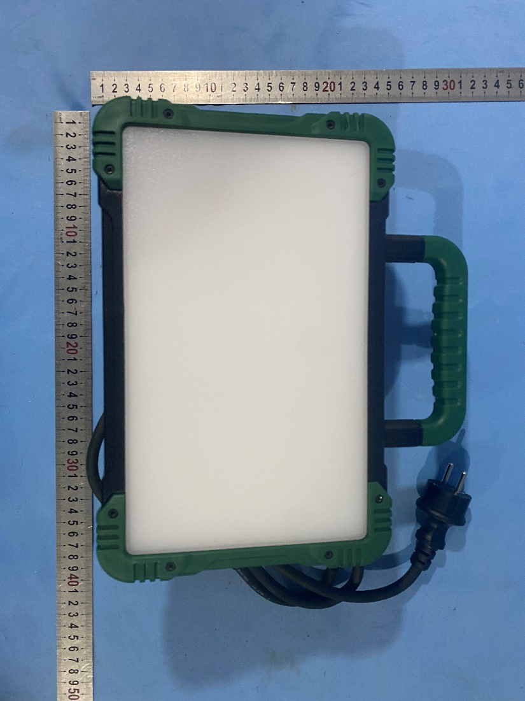

Back view of model ELT2935

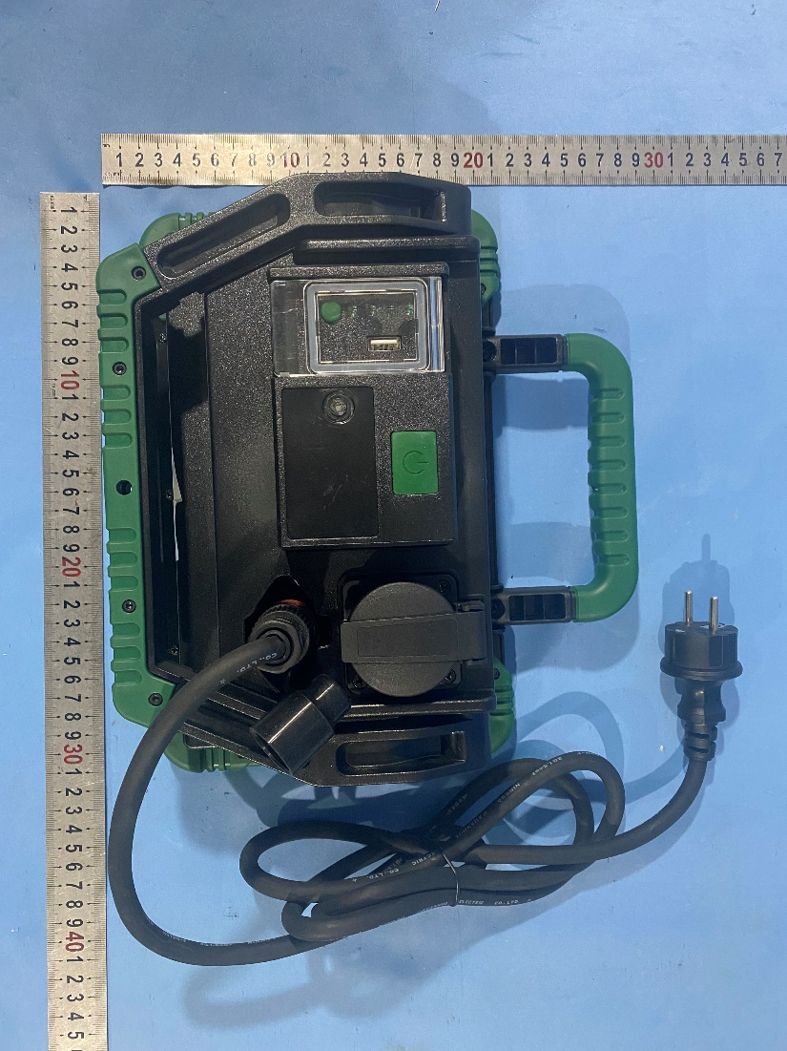

USB Output

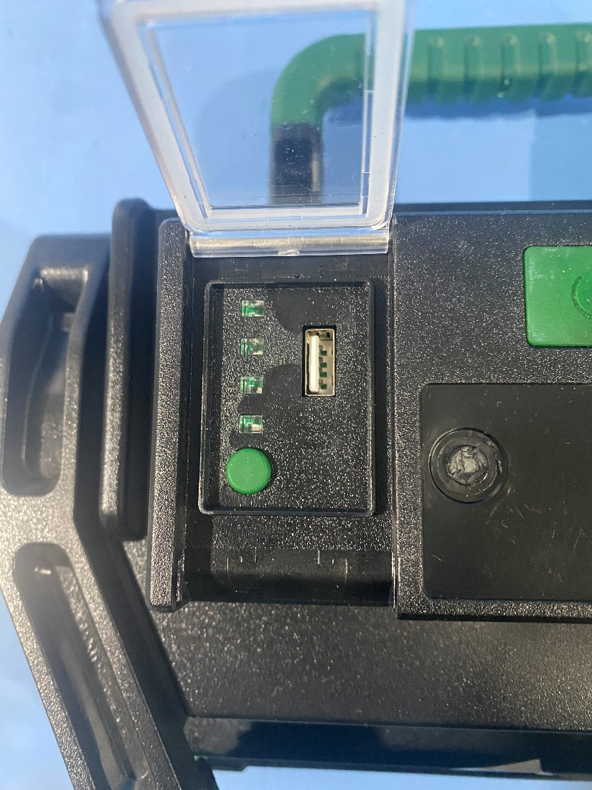

Gasket

Construction

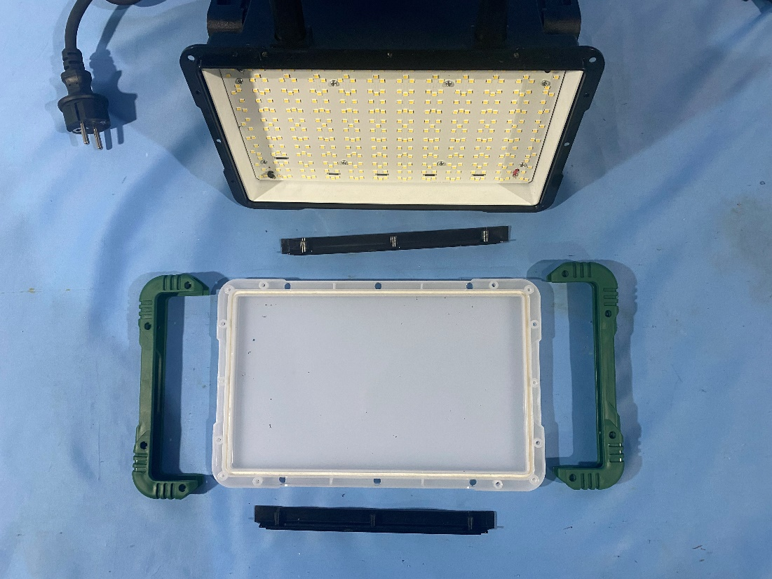

Gasket

LED Models

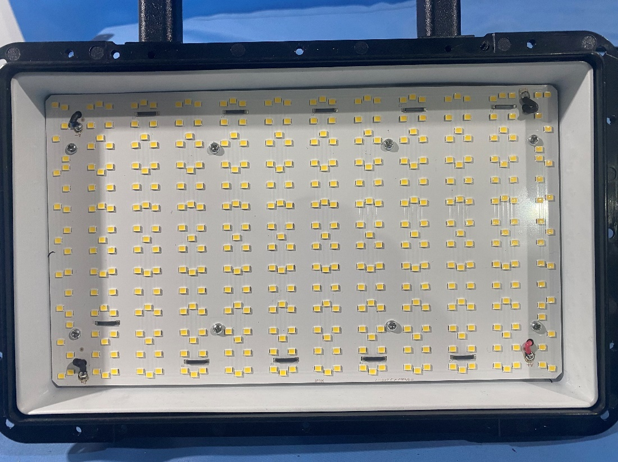

Construction

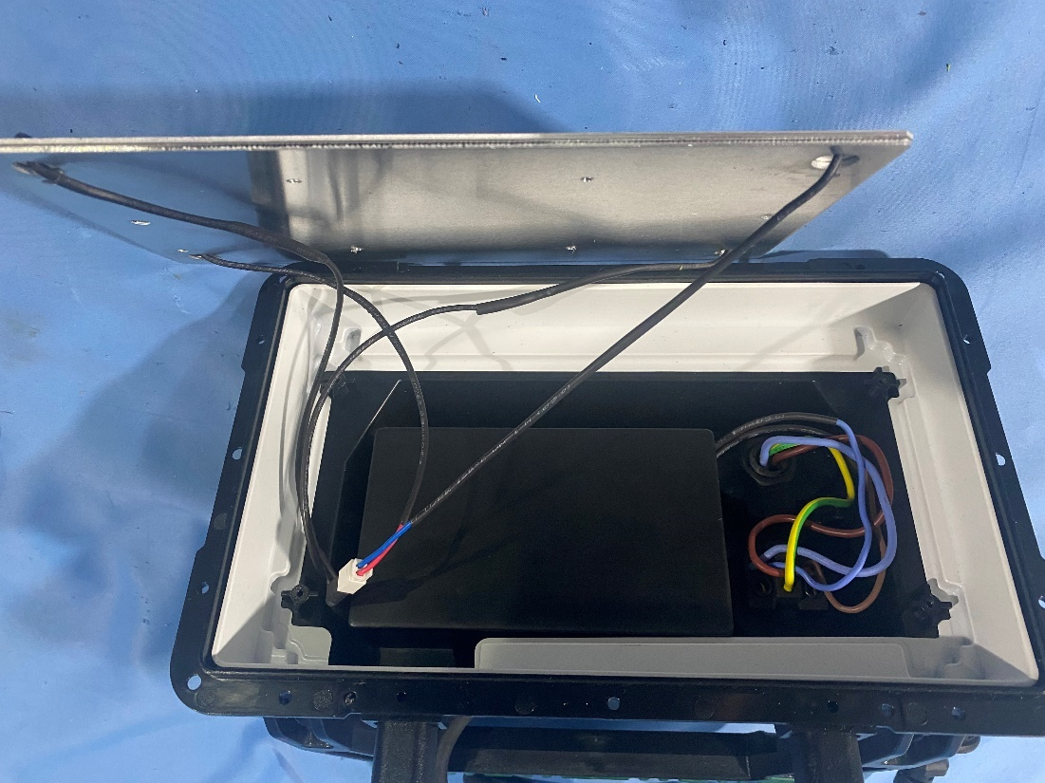

Construction

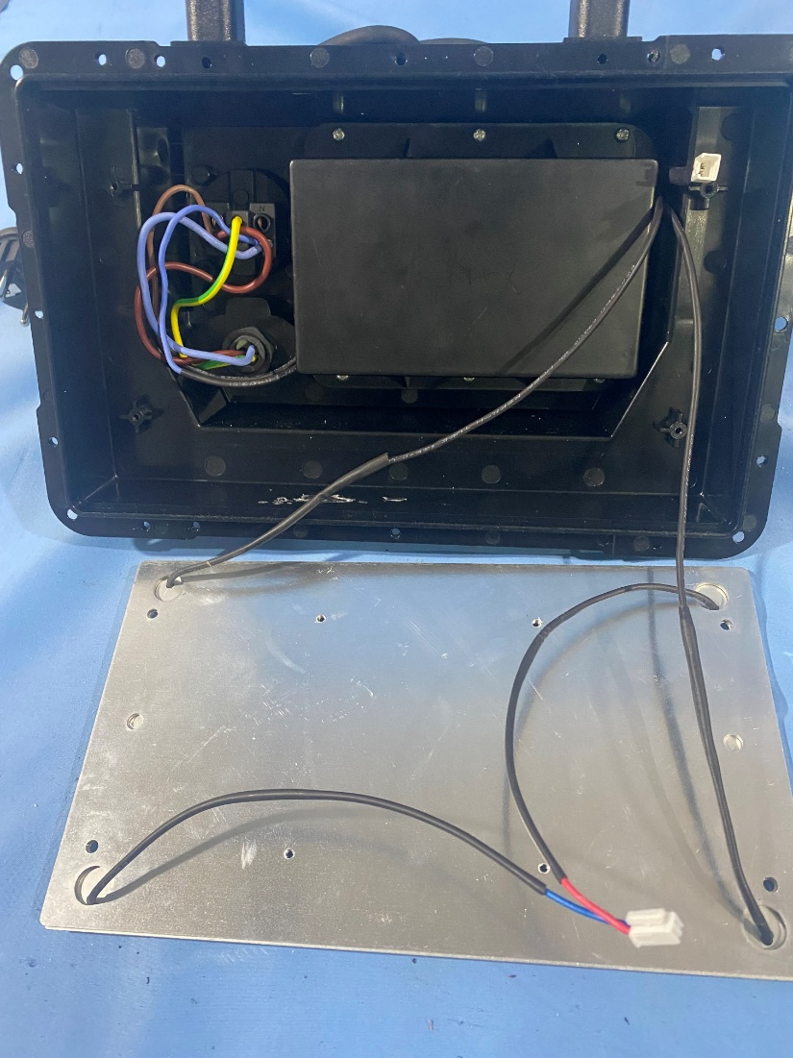

Construction

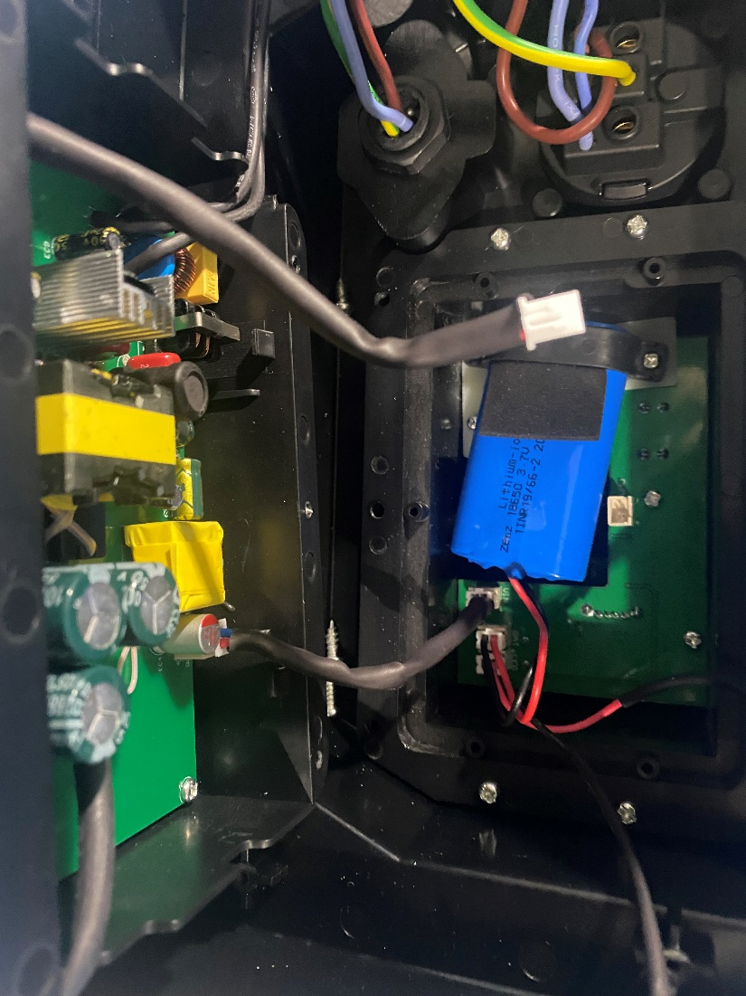

LED Driver ELT2935 A

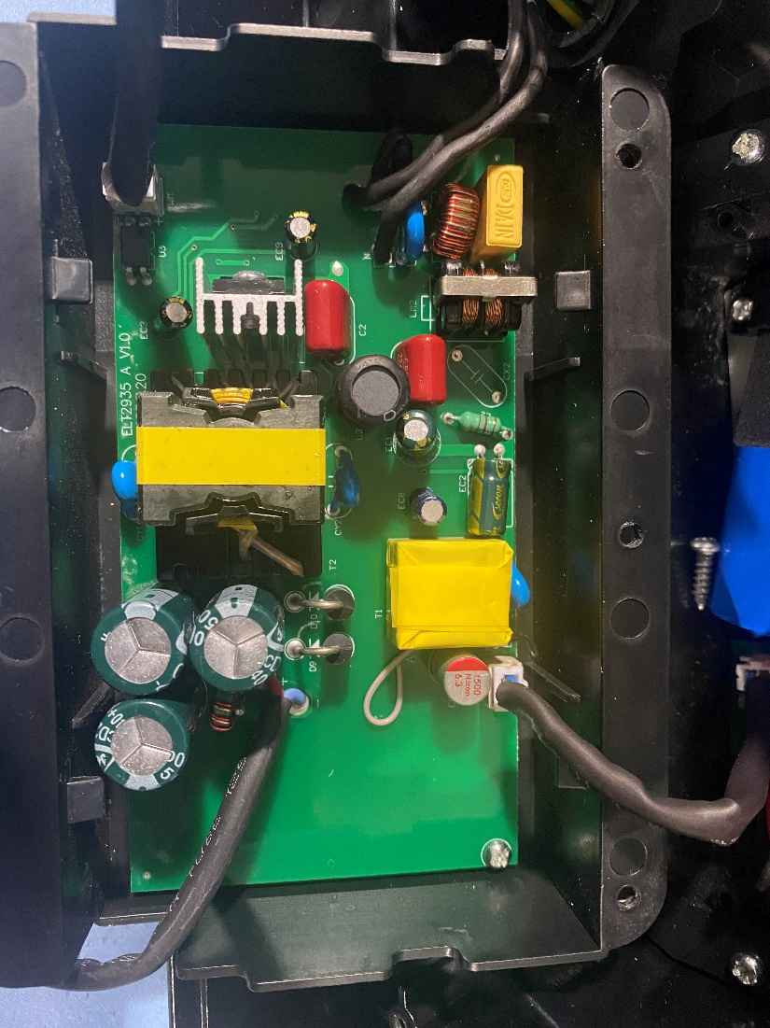

LED Driver ELT2935 A

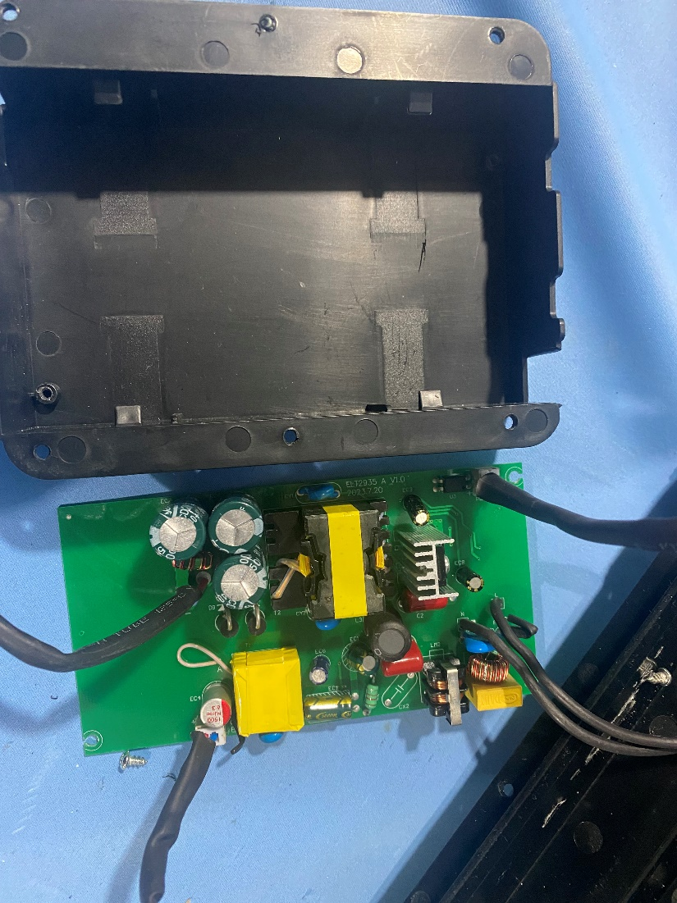

Fuse

LED Driver ELT2935 A

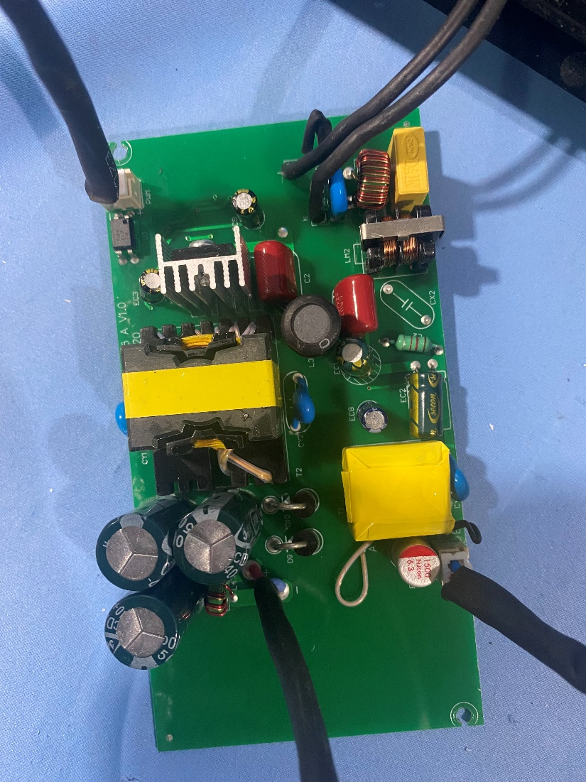

LED Driver ELT2935 A

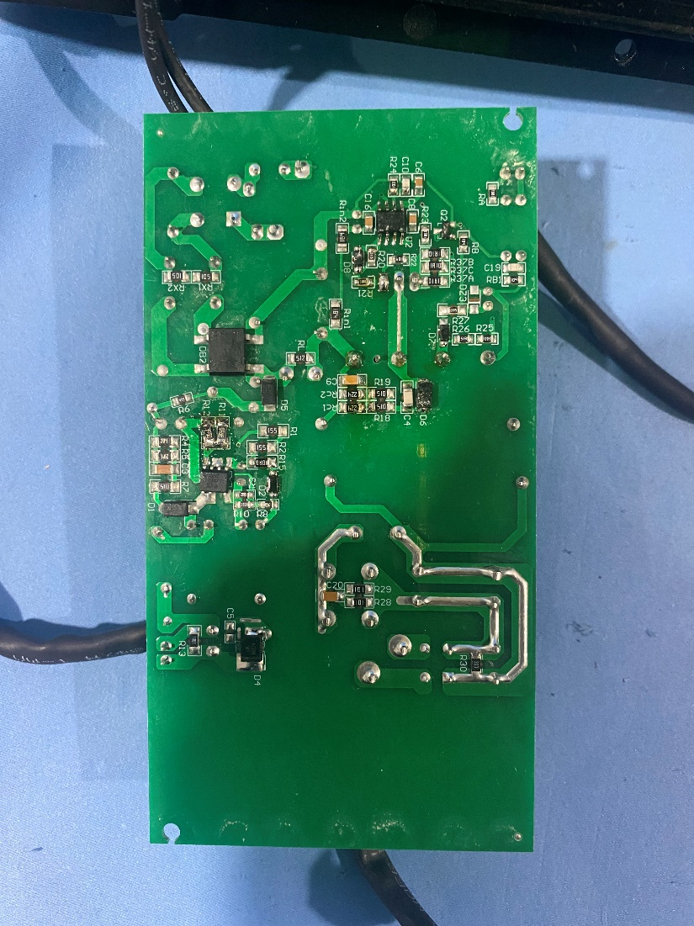

Construction

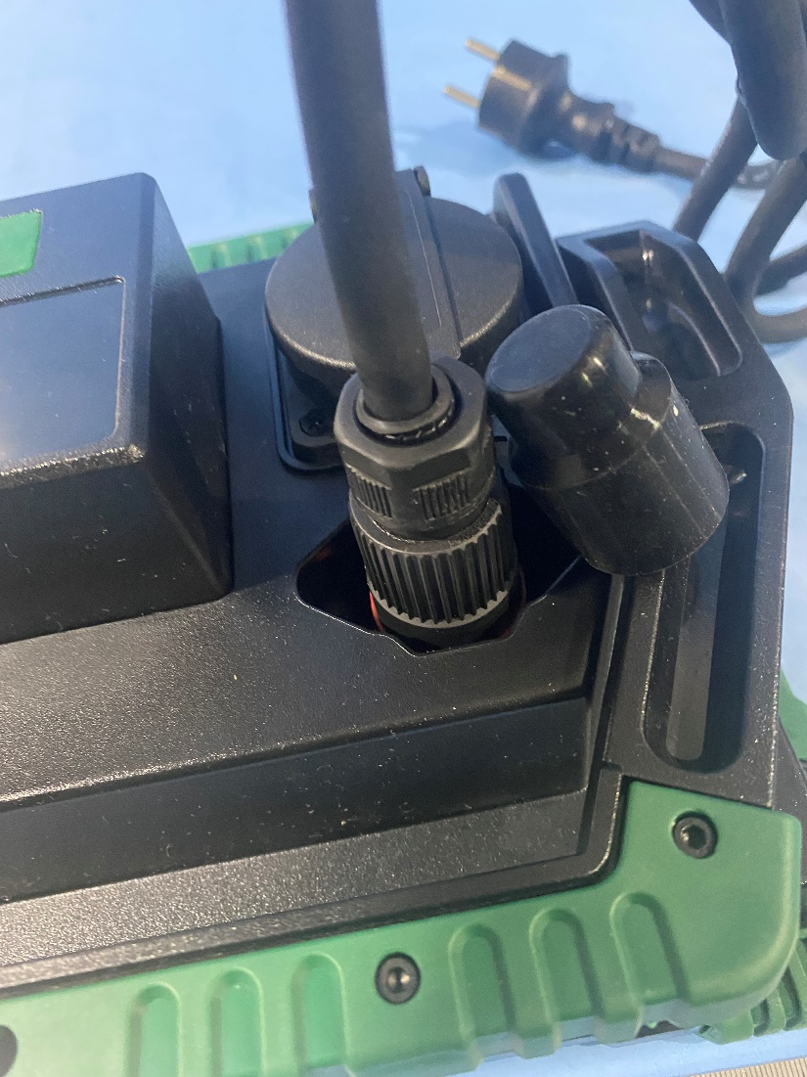

Socket

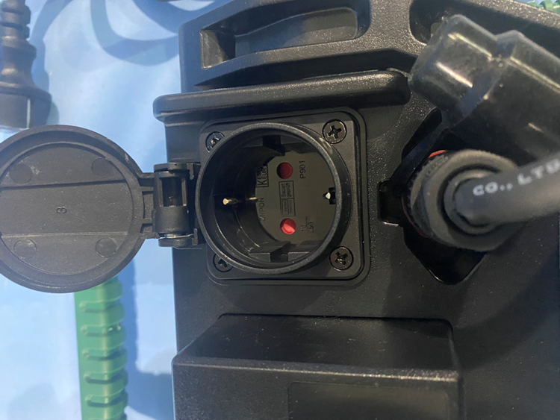

Socket

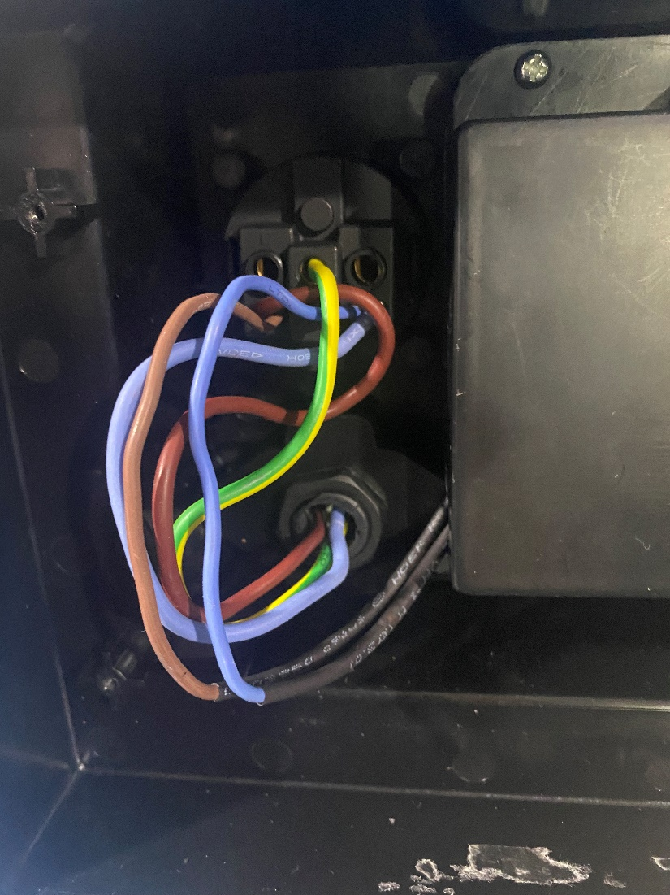

Switch

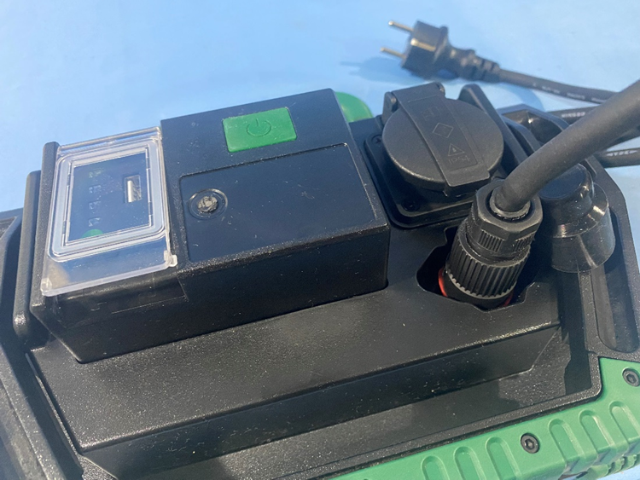

LED driver ELT2935C

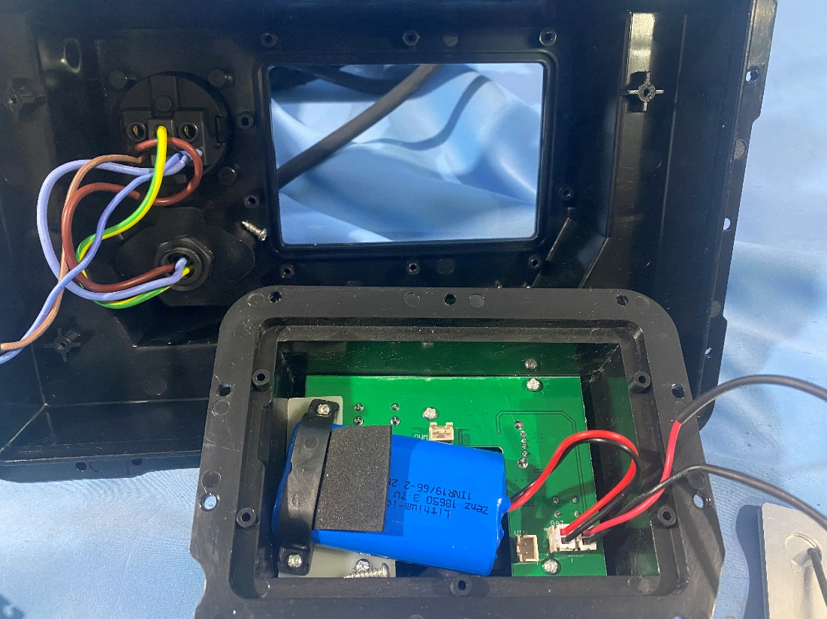

LED driver ELT2935C

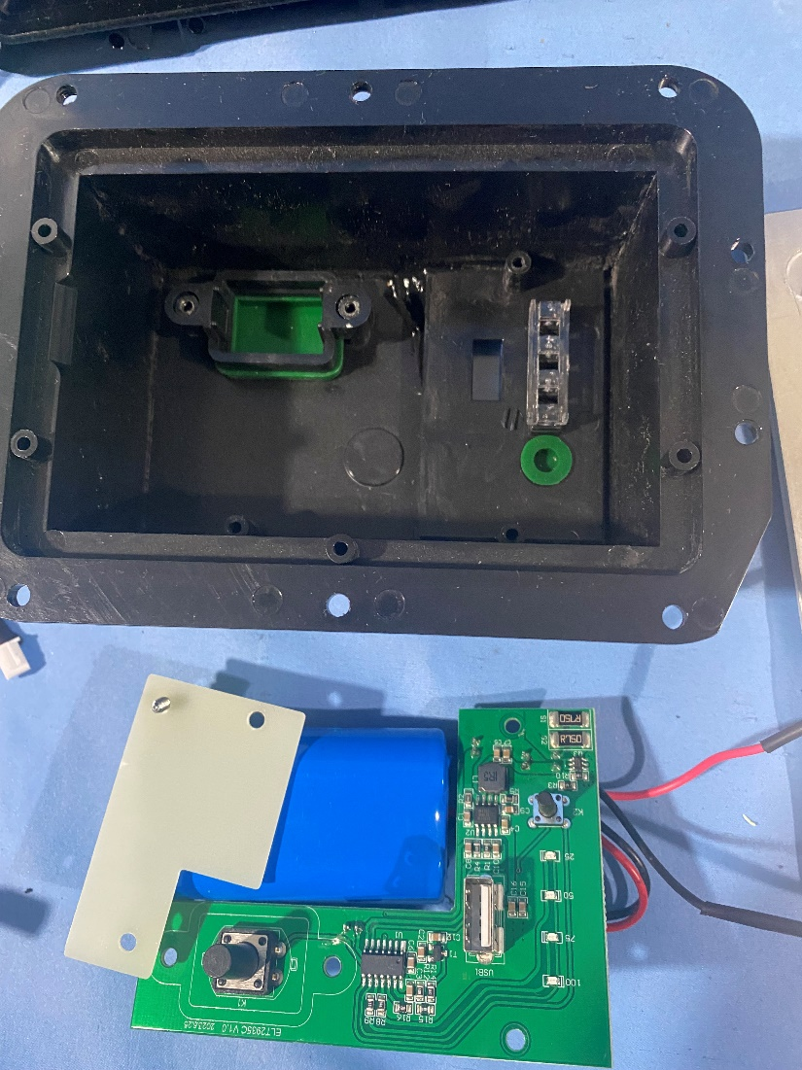

LED driver ELT2935C

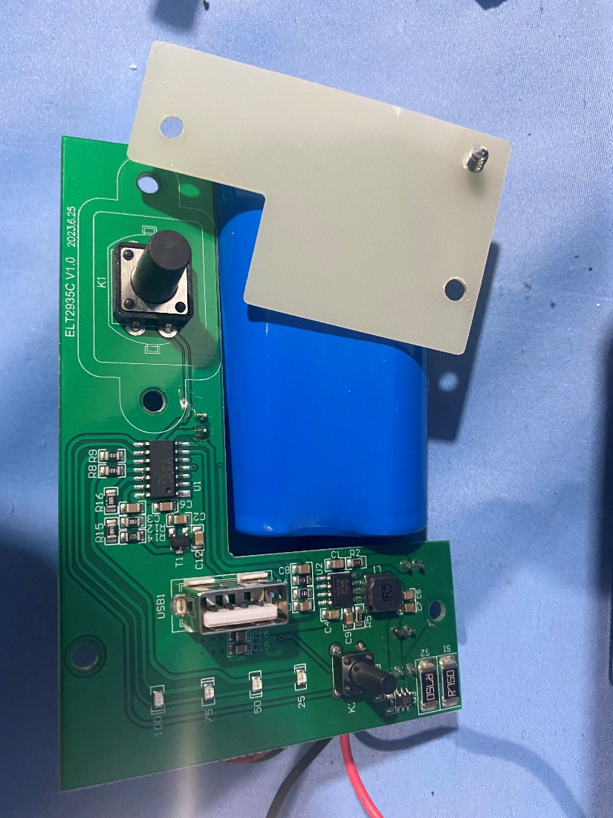

Circuit diagram

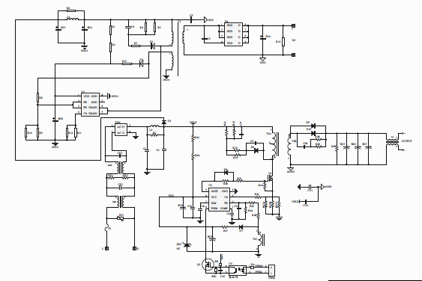

PCB layout for LED driver ELT2935C

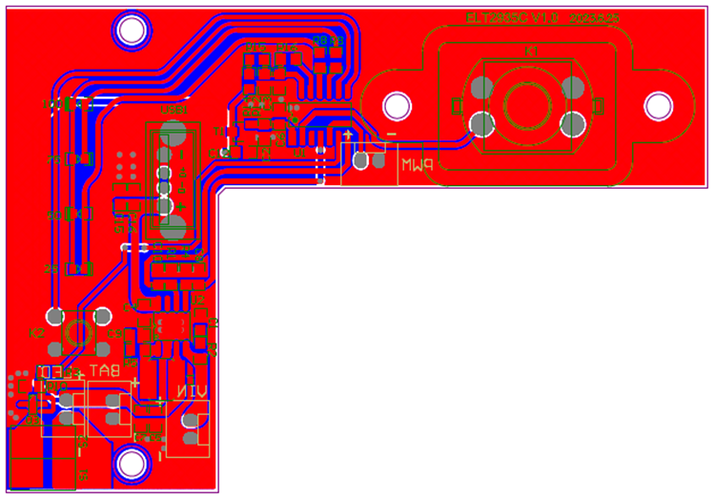

PCB layout for alternate LED modules

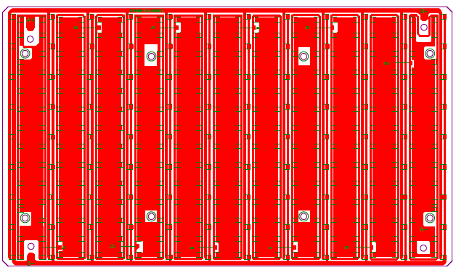

PCB layout for LED driver ELT2935 A

